People’s Democratic Republic of Algeria
Ministry of Higher Education and Scientific Research
Amar Thelidji University – Laghouat
Faculty of Medicine



Medical degree thesis

THEME:
Impact of Simulation on Surgical Training: Laparoscopic Overview

Conducted by: Supervised by:
- Kheloufi Yassmine Fatma • Pr OUALID Mohamed
- Mohguen Amani

Jury members:

• President: Pr Massinissa Benyagoub
• Examiner: Dr Zaabta Abdelkarim

Academic Year: 2024-2025.

Contents

1)Definition of simulation: 9
2)The theoretical foundation of simulation: 9
1. Ericsson’s Theory of Deliberate Practice: 9
2.Miller's pyramid of clinical competence: 9
3. Fitts & Posner’s Three-Stage Model of Motor Learning: 10
3)Purpose of simulation in medical and surgical training: 11
Safe Skill Development Without Risk to Patients 11
Structured and Repetitive Training 11
Standardized and Objective Assessment 11
Enhanced Confidence and Decision-Making 12
Team Training and Communication 12
Cost and Time Efficiency in Training 12
Research and Innovation in Surgical Education 12
4)Target Users of Simulation in Laparoscopic Surgical Training: 12
Surgical Trainees & Residents: 13
Practicing Surgeons : 13
Surgical Assistants & Operating Room (OR) Staff: 13
Interdisciplinary Teams : 13
Certification & Licensing Bodies: 13
Medical Educators & Researchers: 14
5)Metrics for success in laparoscopic simulation training: 14
Performance-Based Metrics (Quantitative): 14
Basic Skills (Beginner Level): 14
Procedural Skills (Intermediate/Advanced Level) 14
Expert-Rated Metrics (Qualitative): 15
Global Rating Scales (GRS): 15
Longitudinal & Real-World Transfer Metrics: 16
Retention Testing: 16
6)Overview of simulation modalities: 17
Virtual reality (VR ) : 17
Augmented reality (AR) : 17
Hybrid simulation (HR): 17
Physical (box trainers): 18
AI-enhanced simulators: 18
LAP Mentor III: 18
1) Definition 18
2)Main keys of LAP Mentor III: 19
3)LAP MENTOR III MODULES: 21
1. Acquire Basic-Level Skills 21
2. ESSENTIAL TASKS MODULE 21
3. BASIC AND ADVANCED STURING MODULE 22
Unlimited Suturing Training 22
5. APPENDICOTOMY MODULE 23
6. Cholecystectomy Procedural Tasks Module 23
7. Cholecystectomy Full Procedure Module 24
8. Cholangiography Module 24
9. Incisional Hernia Module 25
10. Inguinal Hernia Module 25
11. Distal Gastrectomy Module 26
12. Gastric Bypass Module 26
13. Nissen Fundoplication Module 27
15. Nephrectomy Module 28
16. Essential GYN Module 28
Subjects: 29
Study duration: 30
Simulation tool: 30
Assessment process: 30
Data analysis: 31
EXPECTED RESULTS: 31
RESULTS: 33
TASK 01: camera manipulation 0 33
TASK 02: camera manipulation 30 37
TASK 03: eye-hand coordination 39
Task 04: clipping ducts 41
Task 5: peg transfer 44
Limitations :……………………………………………………………………………………………………………………………………..46
Conclusion:………………………………………………………………………………………………………………………………………46

List of diagrams
diagram 1distribution of correct hits 32
diagram 2 distribution of the total path lenght of the camera 33
diagram 3 distribution of total time in both sessions 35
diagram 4 distribution of total path lenght of the camera 37
diagram 5 distribution of total time in both sessions 38
diagram 6 economy of movement right instrument 41
diagram 7 economy of movemt right instrument task 04 43
diagram 8 time needed to complete the task per session 45
diagram 9 number of left instrument movement task 05 47

List of figures:
Figure 1 MILLERS CLINICAL PYRAMID 5
Figure 2 fitts and posners model of motor learning 6
Figure 3 OSATS SCALE 11
Figure 4: AI enhanced simulator 13
Figure 5: the LAP Mentor III VRLS 14
Figure 6: two handed maneuvers 16
Figure 7: translocation of objects 16
Figure 8: clipping and grasping 16
Figure 9: peg transfer 16
Figure 10: ligating loop 16
Figure 11: pattern cutting 16
Figure 12: instructional aids 17
Figure 13: knot tying 17
Figure 14: advanced suturing skills 17
Figure 15: appendix in regular 18
Figure 16: gangrenous preileal appendix position 18
Figure 17:clipping and cutting of retracted gallblader 18
Figure 18: view of safety 18
Figure 19:clipping of bile duct and vessel 19
Figure 20: catheter insertion guided case 19
Figure 21: mesh placement 20
Figure 22: incision 20
Figure 23: vessel exposure and dissection 21
Figure 24: omentum dissection 21
Figure 25: gastro jejunal anastomosis 21
Figure 26: measuring the jejunum 21
Figure 27: nissen task 02 22
Figure 28: nissen task 01 22
Figure 29: spleen mobilization 23
Figure 30: lysis of ahesion 23
Figure 31: prophylactic oophrectomy 23
Figure 32: participant with our superviser DR.M. Oualid performing tasks on the LAP Mentor III 24
Figure 33: participant performing tasks on the LAP Mentor III 24
Figure 34: presentation of our study to mr the minister of higher education on his vist to laghouat simulation center 44

List of tables:

table 1 Success metrics according to skill level 12
table 2 description of simulation modules in the lap mentor III VRLS 27
table 3 task one comparative findings (session one and session two) 30
table 4 task one descriptive statistics 31
table 5 task two comparative findings(session one and session two) 32
table 6 task two descriptive statistics 34
table 7 task three comparative findings (session one and session two) 35
table 8 task three descriptive statistics 36
table 9 task four comparative findings (session one and two) 38
table 10 task four descriptive statistics 39
table 11 task five comparative findings(session one and two) 41
table 12 task five descriptive statistics 43

List of abbreviations:

VR: virtual reality
AR: augmented reality
HR: hybrid simulation
VRLS: virtual reality laparoscopic simulator
OSCE: objective structured clinical exam
FLS: fundamentals of laparoscopic surgery
FES: fundamentals of endoscopic surgery
GRS: global rating skills
OSATS: objective structured assessment of technical skills
OR: operating room
GERD: gastro- oesophageal reflux
GYN: gynecology
TAPP: transabdominal preperitoneal
CI: confidence interval
Mn: minutes
Cm: centimeter

INTRODUCTION:
Driven by the need to improve patient care, medical education is undergoing significant reform. This reform emphasizes a curriculum built upon the cognitive and affective domains of learning, These reforms are framed around best standards of care, errors of management, resource allocation, and patient safety and autonomy. In particular, laparoscopic surgery requires precise hand-eye coordination, depth perception, and mastery of minimally invasive techniques, and presents a steep learning curve for trainees. Traditional apprenticeship models, while valuable, often expose learners to a trial-and-error approach in real surgical settings, which can compromise patient safety and increase operative times.
Simulation-based training offers a controlled, risk-free environment where surgical residents and medical professionals can develop and refine laparoscopic assistance skills before performing procedures on actual patients. High-fidelity virtual reality simulators, box trainers, and hybrid models have been increasingly adopted in surgical curricula to enhance psychomotor skills, improve decision-making, and reduce errors. Studies suggest that simulation training not only accelerates skill acquisition but also improves confidence and operative performance in clinical settings.
Purposes of the Study:
Main Purpose:
This research aims to evaluate the impact of simulation on the development of laparoscopic assistance skills among surgical trainees. By analyzing skill transfer, competency assessment, and long-term retention rates.

General framework on simulation:

1)Definition of simulation:
Simulation in medical and surgical training refers to an educational technique that replicates real-life clinical scenarios using artificial models, virtual reality, or computer-based platforms. It allows learners to practice and refine their skills in a risk-free, controlled environment before performing procedures on actual patients, It can range from low-fidelity models (such as box trainers for laparoscopic skills) to high-fidelity virtual reality (VR) systems that provide realistic anatomical and haptic feedback. The primary goal is to enhance technical proficiency, decision-making, and teamwork while minimizing errors in real clinical practice.

2)The theoretical foundation of simulation:

1. Ericsson’s Theory of Deliberate Practice:
According to Ericsson, "Activities designed to improve performance through repeated practice, feedback, and progressively challenging tasks." Argues that talent is less critical than structured, effortful training; what separates experts from amateurs is thousands of hours of deliberate practice. Many studies confirm that practicing on simulators like the Lap Mentor III accelerates skill acquisition. McGaghie et al. (2011) conducted a meta-analysis that supports the fact that simulation training has better outcomes on medical students' skills than traditional clinical training.

2. Miller's pyramid of clinical competence:
Miller, on the other hand, breaks down competence into four hierarchical levels:
Knows: knowledge in Miller's opinion, constructs the base of the pyramid.
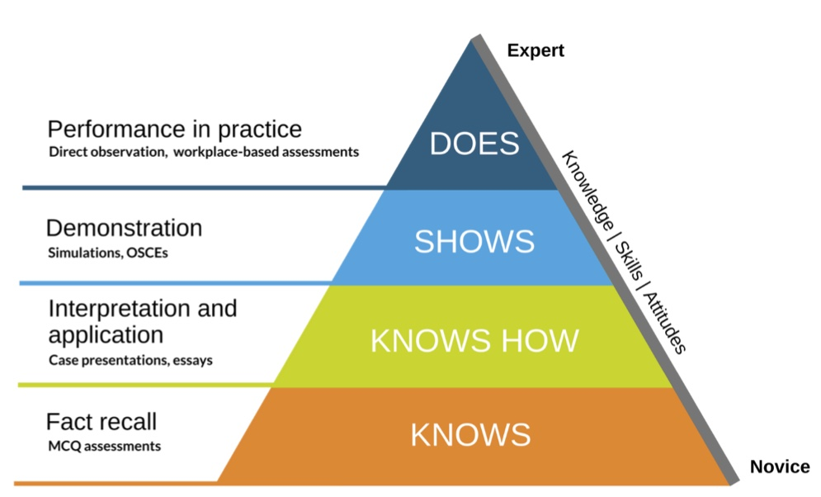
Knows how: knowledge application, where the student can apply the knowledge in context.
Figure 1 MILLERS CLINICAL PYRAMID
Shows how: which is a demonstration of skills in a controlled risk risk-free setting, e.g, OSCE.
Does: top of the pyramid, which reflects real-world performance with real patients under real-world conditions.

3. Fitts & Posner’s Three-Stage Model of Motor Learning:
Based upon observations that different cognitive, perceptual, and motor processes are involved at different points in the learning process, Fitts and Posner (1967) claim that learning takes place in three stages: the cognitive, associative, and autonomous.
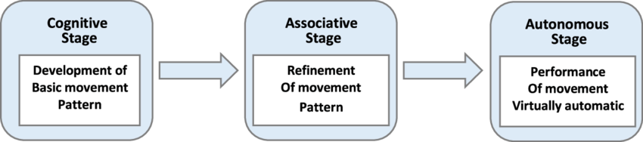

Figure 2 Fitts and Posner's model of motor learning

By projecting this theory on simulation-based training, participants start at the cognitive stage (difficulty in handling instruments) and reach by the end of it, the autonomous stage shown by fluent laparoscopic movements.

3)Purpose of simulation in medical and surgical training:
The primary purpose of simulation in medical and surgical training—particularly in laparoscopic assistance skills, is to bridge the gap between theoretical knowledge and real-world clinical practice by providing a safe and reproducible learning environment. Specifically, the following key purposes:

Safe Skill Development Without Risk to Patients
Allows trainees to practice and make mistakes in a zero-risk setting, eliminating harm to real patients during the learning process.
Reduces complications in actual surgeries by ensuring proficiency before live operations.

Structured and Repetitive Training
Enables deliberate practice of fundamental and advanced laparoscopic skills (e.g., hand-eye coordination, suturing, tissue manipulation).
Facilitates progressive learning from basic tasks to complex procedures.

Standardized and Objective Assessment
Provides measurable performance metrics (time, precision, errors) to track progress.
Ensure all trainees meet uniform competency standards before performing real surgeries.

Enhanced Confidence and Decision-Making
Builds trainee confidence by allowing repeated exposure to surgical scenarios.
Improves crisis management skills through simulated complications (e.g., bleeding, instrument failure).

Team Training and Communication
Simulates real OR dynamics to improve team coordination among surgeons, assistants, and nurses.
Enhance non-technical skills (leadership, situational awareness, communication).

Cost and Time Efficiency in Training
Reduces the need for expensive animal/cadaver labs.
Shortens the learning curve, allowing trainees to achieve competence faster than traditional apprenticeship models.

Research and Innovation in Surgical Education
Serves as a platform for testing new techniques and technologies before clinical application.
Help refine training curricula based on data-driven insights.

4)Target Users of Simulation in Laparoscopic Surgical Training:
Simulation-based training is designed for a wide range of medical professionals. The primary target users include:

Surgical Trainees & Residents:
- Medical students : Introduces foundational laparoscopic skills early in education.
- General surgery residents help develop core competencies before operating on live patients.
- Minimally invasive surgery (MIS) fellows: Refine advanced techniques for complex procedures.

Practicing Surgeons :
- Surgeons transitioning to laparoscopy helps experienced open surgeons adapt to minimally invasive techniques.
- Surgeons learning new procedures: Provides a safe risk-free space to master innovative techniques (e.g., single-incision laparoscopy, robotic-assisted surgery).

Surgical Assistants & Operating Room (OR) Staff:
- Laparoscopic assistants: to train in instrument navigation, camera handling, and team coordination.

Interdisciplinary Teams :
- Anesthesiologists & perioperative teams: Simulates crisis scenarios (e.g., CO₂ embolism, hemodynamic instability).
- Emergency physicians & critical care teams: Practice diagnostic laparoscopy for trauma cases.

Certification & Licensing Bodies:
- Surgical boards & accreditation programs: Uses simulation for objective skill assessment (e.g., FLS, FES).
- Hospital credentialing committees: to help evaluate surgeon competency before granting laparoscopic privileges.

Medical Educators & Researchers:
- Simulation faculty: Simulation tools are often used to design and validate training modules.
- Surgical education researchers: help them study skill acquisition, retention, and transfer to real OR settings.

5)Metrics for success in laparoscopic simulation training:
To objectively evaluate skill progression and training effectiveness, both quantitative (performance-based) and qualitative (behavioral/expert-rated) metrics are used. Below are key indicators for assessing competency at each skill level:

Performance-Based Metrics (Quantitative):

Basic Skills (Beginner Level):
- Task Completion Time:
Time taken to complete drills (e.g., peg transfer, pattern cutting).
Goal: Progressive reduction in time with practice.
- Accuracy & Precision:
Error counts (e.g., dropped objects, deviations from the cutting path).
Economy of motion (measured via motion tracking in VR simulators).
- Instrument Handling Efficiency:
Path length (shorter = more efficient movements).
Number of unnecessary movements.

Procedural Skills (Intermediate/Advanced Level)
- Operative Steps Mastery:
Correct sequence of steps (e.g., cystic artery identification in cholecystectomy).
Time per critical step (e.g., gallbladder dissection).
- Tissue Handling Safety:
Frequency of excessive force (measured via haptic feedback in VR).
Unintended tissue damage (e.g., perforations in simulated bowel).
- Energy Device Use :
- Appropriate activation time and positioning.
- Thermal spread control (avoiding collateral damage).

2.Non-Technical & Team Performance:
- Team Communication:
Clarity of instructions (e.g., camera navigation cues).
Closed-loop communication compliance.
- Situational Awareness:
Recognition of simulated complications (e.g., bleeding, equipment failure).
Appropriate response time to critical events

Expert-Rated Metrics (Qualitative):

Global Rating Scales (GRS):
Structured assessments by instructors (e.g., OSATS scale):
OSATS scale: The Objective Structured Assessment of Technical Skills (OSATS) is a multi-station performance-based examination of surgical skills, first used by the University of Toronto in the 1990s. Stations involve bench model simulations of surgical procedures appropriate to general surgery.
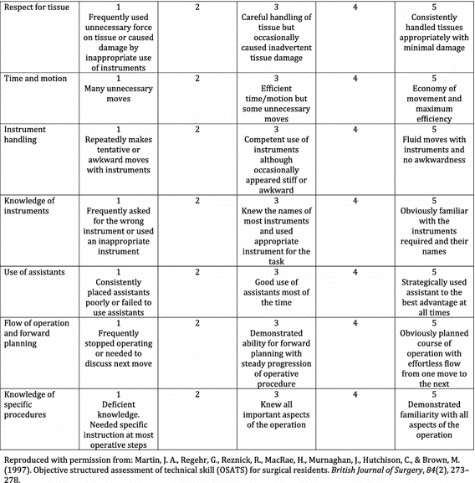
Figure 3 OSATS SCALE

Error Severity Scoring
Minor vs. major errors (e.g., dropped clip vs. bile duct injury).

Debriefing Feedback
Self-assessment vs. expert evaluation alignment.
Identification of improvement areas, such as confidence and realism of simulation.

Longitudinal & Real-World Transfer Metrics:

Retention Testing:
Skill retention after 3/6/12 months without practice.
- Operating Room (OR) Performance Correlation:
Reduced real-patient complications.
Shorter operative times post-simulation training.
- Certification Exam Pass Rates:
Success in standardized tests (e.g., FLS, FES)

  - Simulation-Specific Benchmarks :

Skill level | Key success metrics
beginner | ≤3 errors in peg transfer; 20% faster task completion
intermediate | 90% accuracy in simulated cholecystectomy steps
advanced | <5% tissue damage rate in anastomosis drills
Expert /assessment | OSATS score ≥28/35; FLS certification pass
table 1 Success metrics according to skill level

6)Overview of simulation modalities:

Virtual reality (VR ) :
The use of computer-generated environments to replicate real-world scenarios for training, education, or research. Unlike physical simulations, virtual simulations rely on digital interfaces, such as virtual reality (VR) headsets or screen-based interactive models, to create immersive, interactive experiences.

Augmented reality (AR) :
In simulation education, display-based systems combine real and virtual imagery and are interactive in real time. AR systems allow learners to interact in real-world environments that are enhanced with virtual imagery.

Hybrid simulation (HR):
defined as a modelling approach that combines two or more of the following methods: discrete-event simulation, system dynamics, and agent-based simulation. Example: Some advanced simulators integrate VR with physical manikins for more realistic training.

Physical (box trainers):
Physical box trainers (also called laparoscopic box simulators) are low-fidelity, non-digital surgical training devices designed to teach fundamental laparoscopic skills in a controlled, low-cost environment.
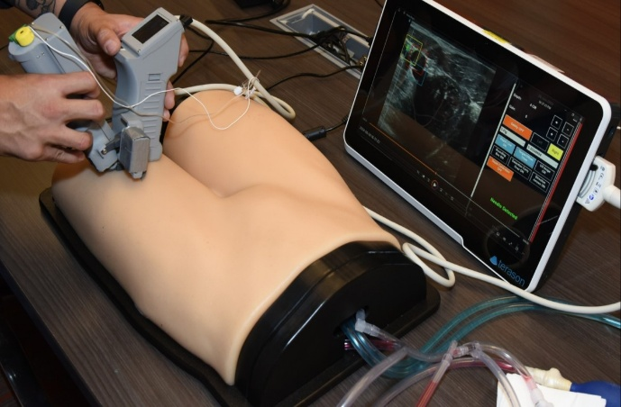
Figure 4: AI enhanced simulator

AI-enhanced simulators:

They are computer-based medical training systems that integrate artificial intelligence (AI) and machine learning (ML) to provide adaptive, personalized, and data-driven feedback for learners. These simulators analyze user performance in real time, adjust difficulty levels, and generate actionable insights to improve skill acquisition.

LAP Mentor III:
- Definition:
LAP Mentor III is a high-fidelity laparoscopic surgery simulator designed for the training of medical staff in minimally invasive surgery. It provides a highly realistic, hands-on learning system based on:
High-resolution 3D anatomical models
Tactile (haptic) feedback
Realistic surgical instruments and tools
It helps students practice and refine various laparoscopic procedures from basic skills like camera handling and suturing to full procedures like appendectomy, cholecystectomy, and gastric bypass in a safe, controlled, and interactive setting.
The system includes performance measurement tools, instructor control (proctor mode), and a vast range of training modules that simulate real-life situations and complications.
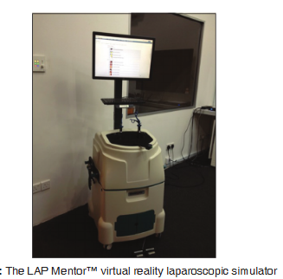
Figure 5: the LAP Mentor III VRLS
Medical simulation center, Faculty of medicine of Laghouat

2)Main keys of LAP Mentor III:
Realistic surgical simulation:
The LAP Mentor III provides accurate tactile feedback, high-resolution anatomical structures, and high-quality realistic imaging. This engineering combination provides a realistic, immersive environment, a close replica of a real laparoscopic operation.
Resources for Educational Growth:
It consists of various forms of didactic materials ranging from 3D anatomical maps, step-by-step real-world videos, interactive instructions, to pre-prepared courses. This helps one learn and acquire skills efficiently.
Evaluation Instruments for Performance:
Objective performance reports and tools for establishing proficiency levels are offered by the simulator. The incorporation of these features facilitates the efficient monitoring of training progression while simultaneously aiding in the identification of specific areas requiring enhancement.
Real-Time Evaluation via Proctor MODE:
During simulations, instructors are afforded the opportunity to intervene, thereby assessing the decision-making capabilities of participants. This mode permits the introduction of complications, alteration of tissue characteristics, and restriction of tool selection, which collectively contribute to the improvement of the training experience.
Comprehensive Module Repository
The LAP Mentor III is equipped with an extensive repository of modules that encompasses fundamental skills, essential procedures, suturing methodologies, and complete simulations across a diverse array of surgical specialties.
Adjustable Ergonomic Features
Designed with user comfort in mind, the simulator promotes optimal training conditions through its adjustable height and configurable monitor positioning, which collectively enhance posture and hand placement during prolonged training activities.
Collaborative Training Functionality
This simulator supports high-fidelity technical training for all individuals involved in a procedure, thereby fostering the development of non-technical competencies such as effective communication, teamwork, and decision-making in both standard and high-pressure contexts.

3)LAP MENTOR III MODULES:

1. Acquire Basic-Level Skills
Allow trainees to acquire skills essential to building confidence and ease with laparoscopic techniques. Exercises in a non-anatomic setting provide a relaxed environment outside of the operating room for both individuals and teams, aimed at improving orientation, eye-hand coordination, and manual skills.
To become familiar with straight and angled camera manipulation
To master eye-hand coordination
To practice clipping and applying
To practice two-handed maneuvers
To perform laparoscopic cutting
To acquire the skill to perform safe and accurate electrocautery
To become efficient at the task of translocating objects

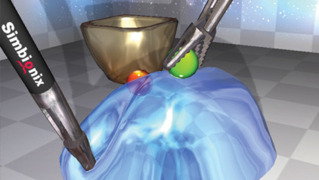
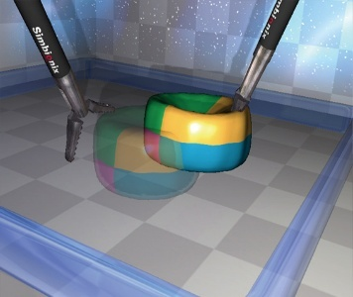
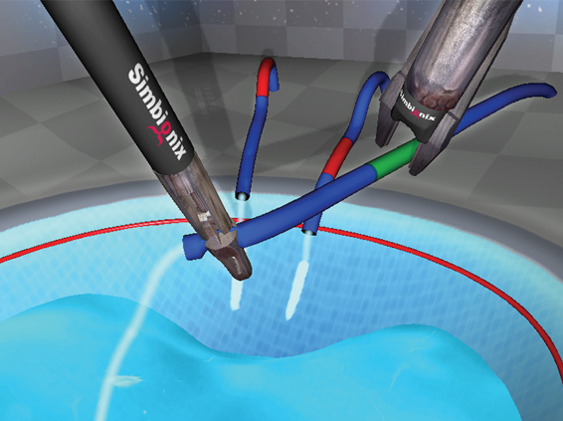
Figure 6: two handed maneuvers
Figure 7: translocation of objects
Figure 8: clipping and grasping

2. ESSENTIAL TASKS MODULE
This module provides practice on three essential tasks, including peg transfer, pattern cutting, and placement of ligating loop, similar to the Fundamentals of Laparoscopic Surgery Program (FLS) developed by the Society of American Gastrointestinal and Endoscopic Surgeons (SAGES).To practice coordinated hand movements and train on use of laparoscopic scissors for cutting, in addition to become accustomed to the fulcrum effect, laparoscopic depth perception and hand-eye coordination
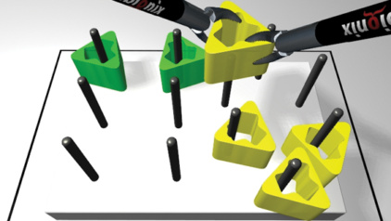
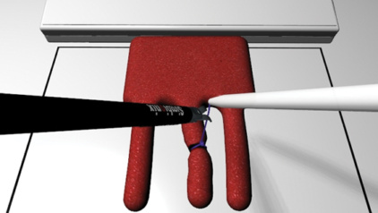
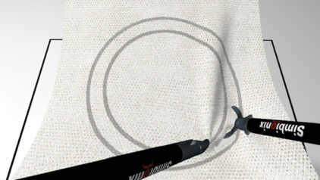
Figure 9: peg transfer
Figure 10: ligating loop
Figure 11: pattern cutting

3. BASIC AND ADVANCED STURING MODULE

Unlimited Suturing Training
Two unique and realistic modules are designed to train until proficient at intracorporeal suturing and knotting techniques for all fields of laparoscopic surgery, including suturing basic skills, such as needle loading, needle insertion, knot tying, interrupted suture, and continuous suture. It helps to learn and practice needle loading and needle insertion techniques and practice suturing in difficult suture line angles as encountered in real life procedures
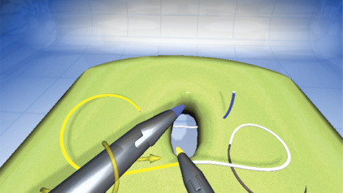
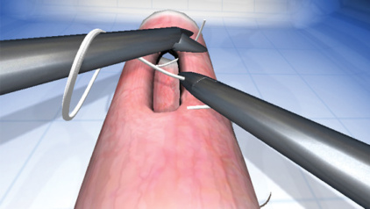
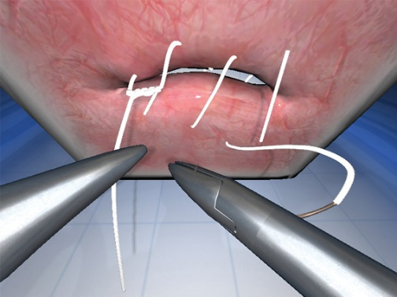
Figure 12: instructional aids
Figure 13: knot tying
Figure 14: advanced suturing skills

4. Camera manipulation module
Train on a set of camera management exercises in a safe, yet fun and engaging environment. This module enables the user to concentrate on obtaining the required camera’s skills, which in turn will be implemented in hands-on practice. Such skills include the correct usage of the horizontal plane, angled optics, zoom and focus.
Learning Objectives:
To practice camera holding and spatial awareness
To maintain and control the horizon
To become familiar with the 0° and 30° camera manipulation and orientation
To practice camera stability, given smaller objects that require skilled handling

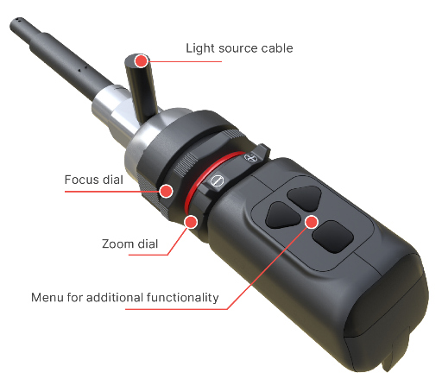

5. APPENDICOTOMY MODULE
Free-hand complete appendectomy procedure cases including anatomical variations, such as a regular, retrocecal and preileal appendix, and various levels of inflammation, such as a moderately inflamed, gangrenous and perforated appendix. The simulation includes high-fidelity tissue response to dissection and realistic bleeding. It also has proctor mode. The proctor can trigger injuries to the appendicular artery, modify tissue stiffness during blunt dissection, and limit the tool selection to resemble a tool malfunction. This module helps in:
Simulation of emergencies such as injury to the appendicular artery, cecum, terminal ileum, iliac vessels, ureter and perforation of the appendix are included so that learners are ready for any complication.

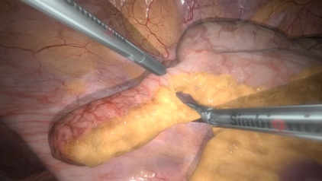
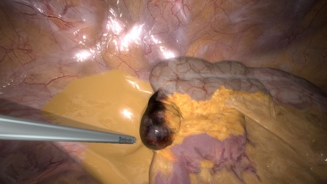
Figure 15: appendix in regular
Figure 16: gangrenous preileal appendix position

6. Cholecystectomy Procedural Tasks Module
This module is a didactic step-by-step tutorial of the laparoscopic cholecystectomy procedure. Each task focuses on one critical stage of the procedure as safe clipping and cutting of the duct and artery, and dissection of the gallbladder from the liver bed. It helps to perform safe exposure of vital structures using correct traction and to become familiar with the anatomy of the gallbladder area

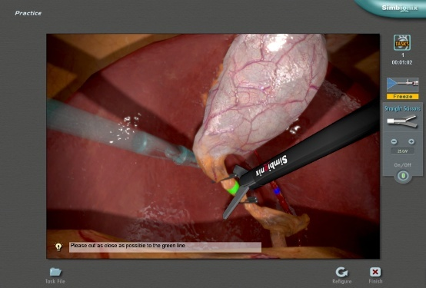
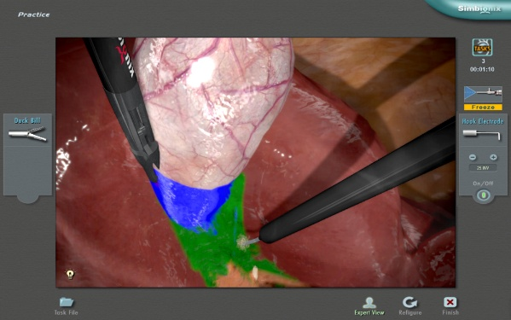
Figure 17:clipping and cutting of retracted gallblader
Figure 18: view of safety

7. Cholecystectomy Full Procedure Module
This module enables free-style training using different techniques, alternative approaches, and the acquisition of the skills and knowledge necessary to safely cope with possible complications. It enables trainees to become familiar with the pitfalls of both easy and difficult anatomical variations to the cystic duct and the position of the arteries.
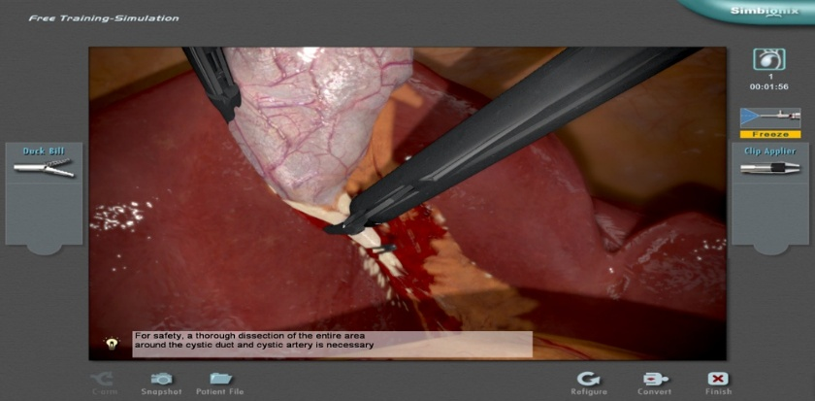
Figure 19:clipping of bile duct and vessel

8. Cholangiography Module
This module allows the trainees to perform the steps of the intra-operative cholangiography procedure in a life-like environment – from the delicate side cut through the complicated insertion of the catheter into the cystic duct, to the injection of contrast agents, it Learns to demonstrate control of the cystic duct with ideally positioned clips
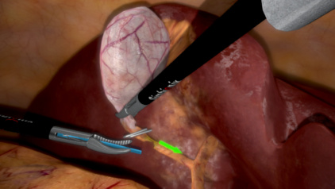
Figure 20: catheter insertion guided case

9. Incisional Hernia Module
This module contains six hernia repair cases, ranging from easy to difficult, providing surgeons with a complete laparoscopic incisional hernia repair procedure training in a controlled and safe environment. To learn the skills for carefully separating the adhesion to expose the hernia defect

10. Inguinal Hernia Module
his module allows users to practice the key steps of the Laparoscopic Transabdominal Preperitoneal (TAPP) Inguinal Hernia repair. A variety of complications and emergencies, such as injuries to the vessels, vas deferens, nerves and bladder. to become familiar with the anatomy of the inguinal region and gain experience in identifying the anatomical landmarks essential for the TAPP Inguinal Hernia repair

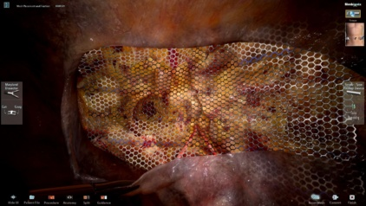
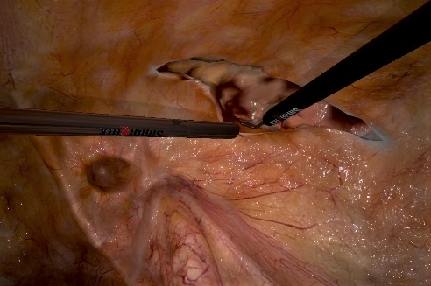
Figure 21: mesh placement
Figure 22: incision

11. Distal Gastrectomy Module
This module offers guidance to the fundamental aspects of the procedure: anatomy identification, dissection of predefined areas, and removal of lymph nodes. Through this module, trainees can acquire skills in averting and addressing potential issues like hemorrhaging from different blood vessels and inadvertent harm to adjacent organs. To perform a preoperational evaluation by exploring the abdominal cavity and identifying different anatomical landmarks, including the tumor and metastasis.

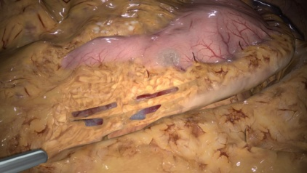
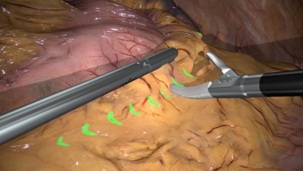
Figure 23: vessel exposure and dissection
Figure 24: omentum dissection

12. Gastric Bypass Module
Provide your surgeons with the opportunity to perform advanced tasks, including creation of the gastric pouch, measurement and division of the jejunum, gastrojejunal anastomosis, and enteroenterostomy anastomosis. Trainees practice the technical aspects of laparoscopic Roux-en-Y creation and jejunojejunostomy and gain an in-depth understanding of intra-operative problems during lap bypass surgery and how to avoid them, to learn the principles and techniques of measuring and dividing the jejunum into duodenojejunal limb and gastrojejunal limb, and to perform gastrojejunal anastomosis

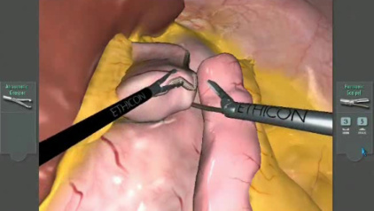
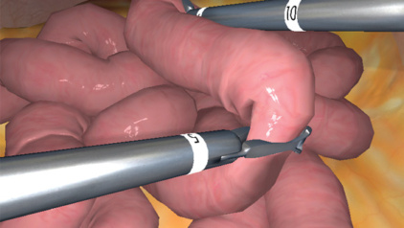
Figure 25: gastro jejunal anastomosis
Figure 26: measuring the jejunum

13. Nissen Fundoplication Module
Ideal for the training of general surgeons, gastrointestinal surgeons, and gastroenterologists, this module with state-of-the-art graphics allows users to practice the key steps of the Laparoscopic Nissen Fundoplication procedure for the treatment of Gastro-Esophageal Reflux Disease (GERD). This includes the dissection of peritoneal ligaments and division of the short gastric vessels. Learns to safely dissect the peritoneal ligaments and separate the esophagus and crura

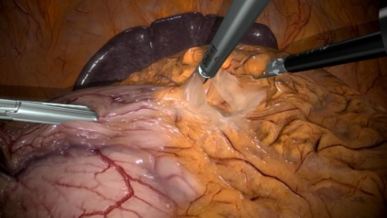
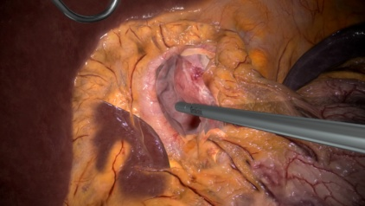
Figure 27: nissen task 02
Figure 28: nissen task 01

14. Sigmoidectomy Module
This module provides the environment to perform a wide range of tasks before encountering them in the operating room, from vessel isolation through the creation of the anastomosis. Trainees learn to determine the best approach for the procedure, practicing real-time clinical decision-making and working safely to prevent complications and respond to injuries and including electro-surgical instruments. It helps to perform the peritoneal incision while elevating the inferior mesenteric pedicle and to learn to appreciate and avoid potential complications

15. Nephrectomy Module
The Transperitoneal Laparoscopic Radical Left Nephrectomy simulation module allows surgeons to practice the necessary skills and required components of the nephrectomy procedure. The procedure includes steps such as colon mobilization, exposure and dissection of the renal hilum, and mobilization of the upper pole. It learns to perform adequate mobilization of the colon from the iliac vessels to the splenic flexure, to mobilize the spleen, and to avoid failure, such as dissection of the postero-lateral attachments.

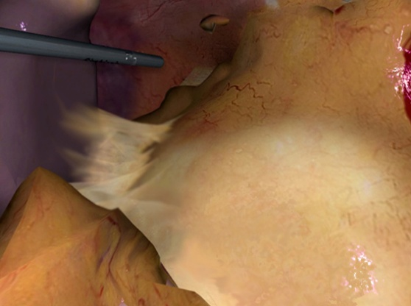

Figure 29: spleen mobilization

16. Essential GYN Module
Seven full-procedure patient cases for training of the fundamental GYN procedures: laparoscopic tubal sterilization, salpingostomy, salpingectomy and salpingo-oophorectomy. Trainees encounter a range of patient pathologies and gain experience with various techniques and surgical instruments. A variety of complications and emergencies are included in this module, such as bleeding at the implantation site, a ruptured fallopian tube and a blood-filled abdominal cavity. It helps to perform proper electro-surgery, to practice using irrigation/suction, to demonstrate knowledge of normal pelvic anatomy and handling of the fallopian tubes

And perform tubal ligation, while avoiding unnecessary trauma

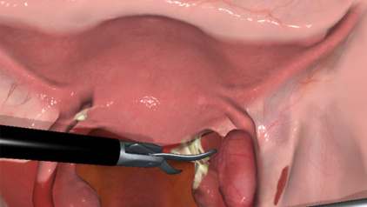
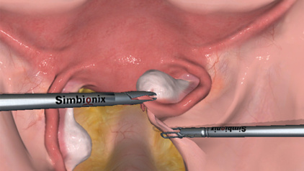
Figure 30: lysis of ahesion
Figure 31: prophylactic oophrectomy

Materials and Methods:

type of the study:
prospective monocentric study comparing two groups: series 1 and series 2

Subjects:
This prospective repeated-measure study was conducted in a single center at the IBN ROCHED simulation center, LAGHOUAT University, Algeria, where the virtual reality laparoscopic simulator (VRLS) was located. The local institution's research and ethics committee approved the study.
The study recruited two participants; both are medical interns during their surgery rotation. with no prior experience in laparoscopy. Consent for the usage of participants' information for the study was obtained prior to the commencement of the study. The team was supervised by Dr. Oualid, M, assistant professor and Head of the Visceral Surgery department at LAGHOUAT University.
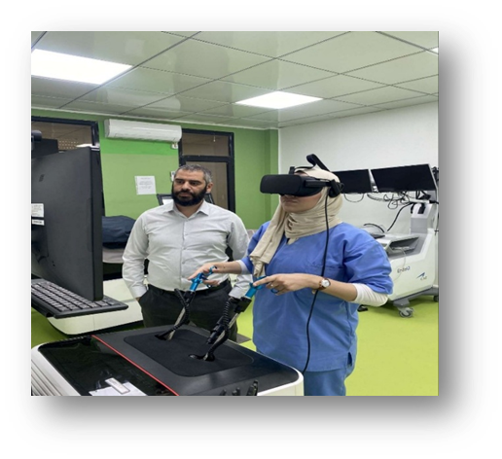
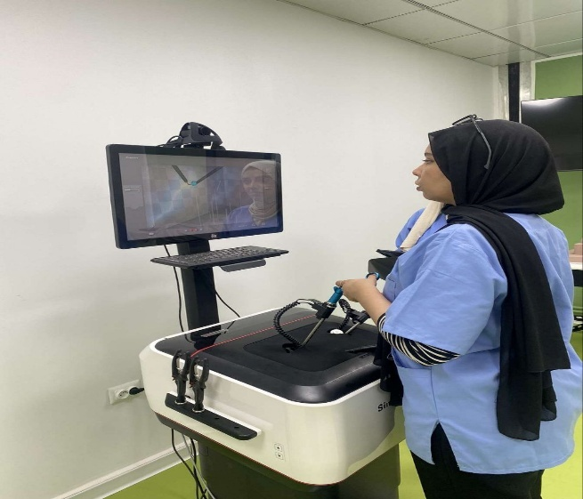
Figure 32: participant with our superviser DR.M. Oualid performing tasks on the LAP Mentor III
Figure 33: participant performing tasks on the LAP Mentor III

Study duration:
after approval from the medical department of Laghouat University, Algeria, this study was conducted over 3 months from January 2025 to March 2025.

Simulation tool:
The LAP Mentor™ VRLS (Simbionix Corporation, Cleveland, Ohio, USA) was used as the simulator for this study. The simulator consisted of a touch-sensitive monitor, body that provides haptic feedback, and two generic laparoscopic instruments, the types of which are chosen through the on-screen menu. For this study, the participants performed different tasks from basic laparoscopic skills modules.

Assessment process:
Before beginning the simulation training, each participant performed a standardized baseline task on the LAP Mentor III camera navigation, without prior training, to establish initial performance metrics. Following this, participants underwent a series of structured simulation sessions on the LAP Mentor III, which included five tasks of the basic skills modules. The tasks included: camera manipulation 0 degree, camera manipulation 30 degree, eye and hand coordination, clip and grasp, peg transfer. All participants followed the same training schedule to ensure consistency. During these sessions, the LAP Mentor III automatically collected objective performance data, including task completion time, instrument path length, number of errors, accuracy, and economy of movement. After the training phase, participants repeated the initial tasks to assess improvement and filled out a post-assessment questionnaire that captured subjective feedback regarding their confidence and the realism of the simulation experience. The study maintained high ethical standards, ensuring informed consent, confidentiality, and approval from the relevant institutional review board.
Data analysis:
SPSS version 19 was used for data entry and analysis. Descriptive statistics were also used to analyze minimum, maximum, and average scores with standard deviation (SD) on each station and overall performance.

EXPECTED RESULTS:
In this comprehensive study, we anticipate that the utilization of the LAP MENTOR III will significantly enhance the trainee's laparoscopic skills by reducing errors and improving surgical performance through repetitive, measurable, and structured practice. Preliminary analyses of the gathered data indicate a promising potential for the LAP MENTOR III as a simulation tool.
Specifically, we expected that both participants would spend less time on the second session tasks than on the first one, and shorter path length compared to the first session. Conversely, an increasing percentage of target hits. We also expect that the trainees report higher self-efficacy.

Simulation Experience Feedback Questionnaire
Section 1: Participant Confidence
Please indicate the extent to which you agree with the following statements. Use the scale:
1 = Strongly Disagree | 2 = Disagree | 3 = Neutral | 4 = Agree | 5 = Strongly Agree

- I felt confident in my ability to perform the required tasks during the simulation.

- The simulation helped me identify areas where I need to improve my skills.

- I feel more prepared to handle similar situations in a real-life setting after this simulation.

- I was able to apply theoretical knowledge confidently during the scenario.

- My performance in the simulation increased my overall confidence in this
Domain.
-----------------------------------------------------------------------------------------------------
Section 2: Realism of the Simulation
Please rate your agreement with the following statements:

- The simulation felt realistic and closely resembled real-world scenarios.

- The environment (equipment, setting, time pressure) contributed to the realism of the scenario.

- The behaviors of actors or simulated patients added to the authenticity of the experience.

- The challenges presented during the simulation reflected what I might face in actual practice.

- The simulation allowed for realistic decision-making and problem-solving.
----------------------------------------------------------------------------------------------------
Section 3: Open-Ended Feedback
- What aspects of the simulation did you find most realistic?

- What aspects seemed unrealistic or artificial?

- How did the simulation affect your confidence in real-world practice?

- What improvements would you suggest for future simulation sessions?

table 2 Description of simulation modules in the Lap Mentor III VRLS

Skill or task | Description
Basic skill:  Camera manipulation 0°  Camera manipulation 30°  Eye-hand coordination  Clipping and grasping  Peg transfer | Using a 0° camera, locate and snap the ten balls in an abstract environment.  Using a 30° camera, locate and snap the ten balls in an abstract environment.  Locate the flashing ball and touch with the appropriate colored tool  Safely grasp the leaking ducts and clip  within a speciﬁed segment  Safely grasp the leaking ducts and clip  within a speciﬁed segment  Safely grasp the leaking ducts and clip within a speciﬁed segment  Transfer the peg from one side to another while switching hands as needed

RESULTS:
There were a total of 2 participants, both are medical interns during their surgery rotation. with no prior experience in laparoscopy, who completed the full five tasks mentioned earlier

TASK 01: camera manipulation 0
The total time: required to complete each session (session 01= 1,86 Minutes ) and (session 02=1,60 Minutes ). The reduction in time suggested a remarkable efficiency, though the p-value(0,367) indicates that the difference is not statistically significant. The 95 % CI [-0.33; 0.85] including the zero supports the lack of significance.
The number of correct hits: in each session (session 01=9,3) and (session 02=9,8) increases(0,5 hits), is statistically significant, given that (p=0,025). The 95 % CI [-1.11; -0.08] does not include zero.

diagram 1distribution of correct hits

The percentage of target hits: in each session (session 01=73,05) and, session 02=75,85 %), there is a slight improvement(2,8%) but not statistically
significant(p=0.628), and the 95% CI [-14.7; 9.13] includes zero.
The total path length of the camera(cm): in each session,(session 01=610.98 cm) and (session 02=382.18). This reduction is significant (p= 0.016) with a 95% CI [48.12; 409.47] not including zero.

diagram 2 distribution of the total path lenght of the camera

The number of camera shots: in session 01=12.60 and in session 02=12.30.
There is a slight reduction(0.30) statistically not significant (p = 0.704), with a 95% CI [-1.33; 1.93] including zero.

Parameter | Serie 1 | Serie 2 | P value* | CI 95%
Total time  Mean (mn) | 1.86 | 1.60 | 0.367 | [-0.33 ; 0.85]
Number of correct hits | 9.3 | 9.8 | 0.025 | [-1.11 ; -0.08]
Target hits% | 73.05 | 75.85 | 0.628 | [-14.7 ; 9.13]
Total path length of the camera(cm) | 610.98 | 382.18 | 0.016 | [48.12 ; 409.47]
Number of camera shots | 12.60 | 12.30 | 0.704 | [-1.33 ; 1.93]
table 3 task one comparative findings (session one and session two)
To have a broader view of the performance, the following table provides the mean, median, min, and max values:

The Total time: The median is lower than the mean, suggesting skewed data.
Number of correct hits: the median matches the maximum(10), indicates that participants achieved perfect scores.
Target hits: (min: 52.6%) and (max: 100%), a wide range that reflects variability in performance among participants.
Total path length: the wide range(242.3-859.7) reflects variability in performance among participants.

table 4 task one: descriptive statistics

parameter | Mean | median | Min-max
Total time (mn) | 1.73 | 1.48 | 1.12-3.17
Number of correct hits | 9.6 | 10 | 8-10
Target hits% | 74.45 | 76.6 | 52.6-100
Total path length of the camera(cm) | 496.58 | 457.6 | 242.3-859.7
Number of camera shots | 12.45 | 12 | 9-15

TASK 02: camera manipulation 30
The total time: required to complete each session (session 01=2.09) and (session 02 = 1.27) shows a statistically significant decrease in time (p = 0.04).

diagram 3 distribution of total time in both sessions

The number of correct hits: in session 01=9.5 and session 02= 10, with a (p =0.05), shows almost a ceiling result, knowing that max 10.
Also, target hits have improved from 69.14% to 79.74%, but not significantly (p=0.30), and a wide CI 95% .
table 5 task two comparative findings(session one and session two)

Parameter | Serie 1 | Serie 2 | P value* | CI 95%
Total time  Mean (mn) | 2.09 | 1.27 | 0.04 | [-0.03 ; 1.6]
Number of correct hits | 9.5 | 10 | 0.05 | [-1 ; 0.00]
Target hits% | 69.14 | 79.74 | 0.30 | [-31.72 ; 10.5]
Total path length of the camera(cm) | 483.19 | 317.89 | 0.01 | [-54.25 ; 385.8]
Number of camera shots | 14.8 | 14.4 | 0.88 | [-5.43 ; 6.14]

The total path length of the camera in each session (session 01=483.19cm) and (session 02=317.89 cm); this reduction is significant(p=0.01).

diagram 4 distribution of the total path length of the camera

The number of camera shots: in session 01=14.8 and session 02= 14.4, with a (p = 0.88), not statistically significant change.

parameter | Mean | Median | Min-Max
Total time (min) | 1.68 | 1.19 | 1.00-3.30
Number of correct hits | 9.75 | 10.00 | 8.00-10.00
Target hits% | 74.44 | 76.90 | 31.30-100
Total path length of the camera(cm) | 400.54 | 292.80 | 170.00-921.00
Number of camera shots | 14.60 | 12.00 | 10.00-32.00

To have a broader view of the performance, the following table provides the mean, median, min, and max values:
table 6 task two: descriptive statistics

The Total time:
the mean= 1.68 included in the min/max range [1.00-3.30]
Total path length: The mean 400.54 included in the min/max range with max=921.00.

TASK 03: eye-hand coordination
The total time: needed to complete each session has significantly decreased as shown in the table and the (p=0.02), which makes it a statistically significant decrease.

diagram 5 distribution of total time in both sessions
Parameter | Serie 1 | Serie 2 | P value* | CI 95%
Total time  Mean (min) | 0.87 | 0.50 | 0.02 | [0,04 ; 0.69]
Number of touched balls | 10.7 | 11.9 | 0.12 | [-2.75 ; 0.35]
Economy of movement right instrument | 45.6 | 42.9 | 0.71 | [-12.78 ; 18.22]
Economy of movement left instrument | 35.2 | 53.1 | 0.03 | [-33.9 ; -1.83]
Touched target | 83.7 | 88.1 | 0.30 | [-13.23 ; 4.33]
The number of touched balls: shows an increase after the first session, but an insignificant one(p=0.12).

The economy of movement: right instrument as shown on the table, no significant change (p=0.71), on the opposite, the data coming from the left instrument shows a significant improvement(p=0.03).
For a broader view of the performance, the following table provides the mean, median, min, and max values:
The Total time: the Median (0.51 min) < Mean (0.69 min) indicates a positive skew in data.
The Economy of movement: especially the left instrument shows a huge range
(12-89.60).
table 7 task three comparative findings (session one and session two)

Touched targets: some trainees reached the High max 100% at the end of the task.
table 8 task three: descriptive statistics
parameter | Mean | Median | Min-Max
Total time (min) | 0.69 | 0.51 | 0.32-1.55
Number of touched balls | 11.30 | 11.00 | 8-16
Economy of movement, right instrument | 44.26 | 48.30 | 14-67.70
Economy of movement left instrument | 44.23 | 43.45 | 12-89.60
Touched target | 85.91 | 85.40 | 64.30-100
Task04: clipping ducts
Total Time: The time to complete the task significantly decreased from 1.82 minutes (session 1) to 1.28 minutes (session 2), with a p-value of 0.01, indicating a statistically significant improvement. .
Economy of Movement (Right Instrument): There was a significant improvement in the economy of movement using the right instrument, with the path length decreasing from 45.49 cm to 65.7 cm (p=0.001). .

diagram 6 economy of movement right instrument

Economy of Movement (Left Instrument): Similar to the right instrument, the left instrument showed a significant improvement in economy of movement, with a decrease from 39.5 cm to 53 cm (p=0.007).
Applied Clips: The number of applied clips increased significantly from 71.74% in session 1 to 89.7% in session 2, with a p-value of 0.006.

To have a broader view of the performance, the following table provides the mean, median, min, and max values:

table 9 task four comparative findings (sessions one and two)
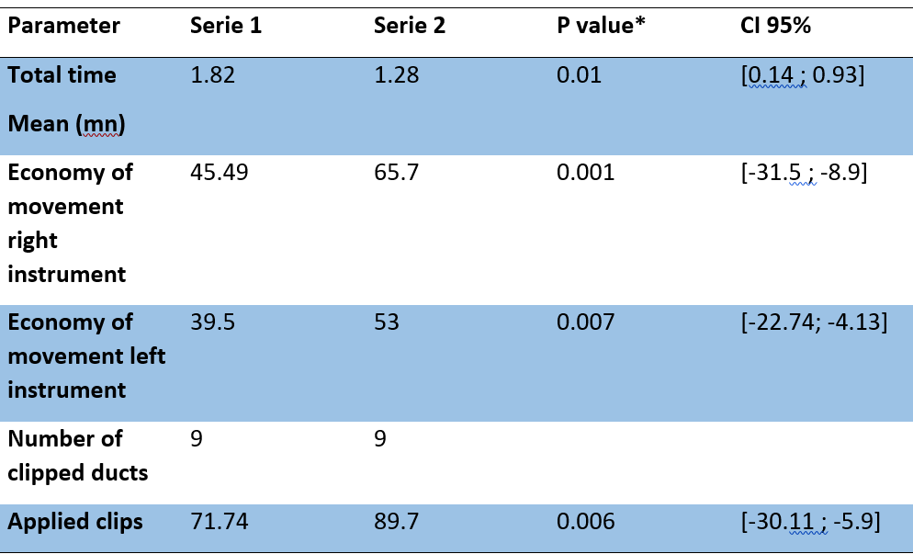

table 10 task four: descriptive statistics
Parameter | Mean | Median | Min-Max
Total time (mn) | 1.55 | 1.33 | 1.17-3.03
Economy of movement right instrument(cm) | 55.60 | 52.60 | 29.90-81
Economy of movement left instrument (cm) | 46.28 | 47.15 | 24.00-61
Number of clipped ducts | 9 | 9 | 9-9
Applied clips | 80.75 | 81.80 | 47.40-100

Total Time: The median is lower than the mean, suggesting skewed data.
Economy of Movement (Right Instrument): The median is close to the mean, though the min-max range indicates there was still variability in movement efficiency.
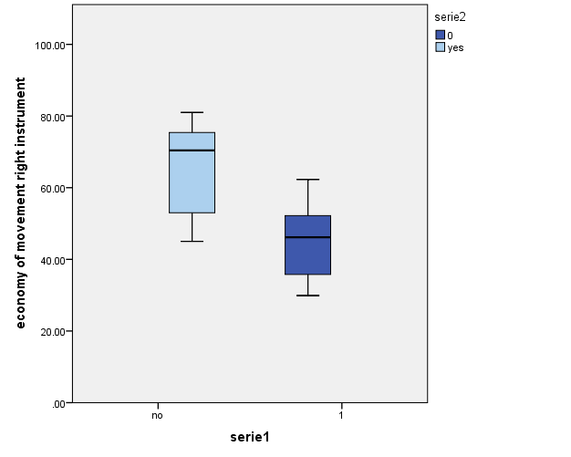
diagram 7 economy of movement right instrument task 04
Economy of Movement (Left Instrument): The mean and median values are very close, suggesting that the data is relatively balanced for the left instrument. However, the wide range indicates some inefficiency in movements among participants.
Number of Clipped Ducts: The mean, median, and min-max values are identical, indicating consistent performance across participants.
Applied Clips: The mean and median are close, suggesting consistency in the applied clips across most participants. However, a wide range (47.40% to 100%).

Task 5: peg transfer
Time to Complete: The time to complete the task decreased slightly from 145.7 minutes (session 1) to 113.7 minutes (session 2), but the p-value of 0.07 indicates that this change is not statistically significant.
Number of Movements (Left Instrument): The left instrument showed a decrease in the number of movements, from 218.2 movements in session 1 to 174.5 in session 2. However, the change was not statistically significant (p=0.10).

diagram 8 time needed to complete the task per session
Number of Movements (Right Instrument): The right instrument also showed a decrease in movements from 219.7 in session 1 to 178.6 in session 2, but the change was not statistically significant (p=0.14). .
Total Path Length (Right Instrument): The total path length for the right instrument reduced from 394 cm in session 1 to 317.3 cm in session 2, though the p-value of 0.15 indicates that the difference is not statistically significant.
Total Path Length (Left Instrument): The path length for the left instrument also showed a decrease from 389.6 cm in session 1 to 329.6 cm in session 2, but the difference was not statistically significant (p=0.26).

Parameter | Serie 1 | Serie 2 | P value* | CI 95%
Time to complete (mn) | 145.7 | 113.7 | 0.07 | [-4.63 ; 68.6]
number of movements left instrument | 218.2 | 174.5 | 0.10 | [-9.68 ; 97.09]
number of movements right instrument | 219.7 | 178.6 | 0.14 | [-14.8 ; 97.46]
Total path length of right instrument | 394 | 317.3 | 0.15 | [-32.7 ; 186.45]
Total path length of left instrument | 389.6 | 329.6 | 0.26 | [-48.85 ; 169.19]
table 11 task five comparative findings(session one and two)

To have a broader view of the performance, the following table provides the mean, median, min, and max values:
Time to Complete: The median is lower than the mean, indicating skewed data
a wide range (91–251 minutes) was also observed.
Number of Movements (Left Instrument): The median is slightly lower than the mean.
The range (130–395) shows significant variability.
Number of Movements (Right Instrument): The median is lower than the mean, again suggesting some skewness in the data.
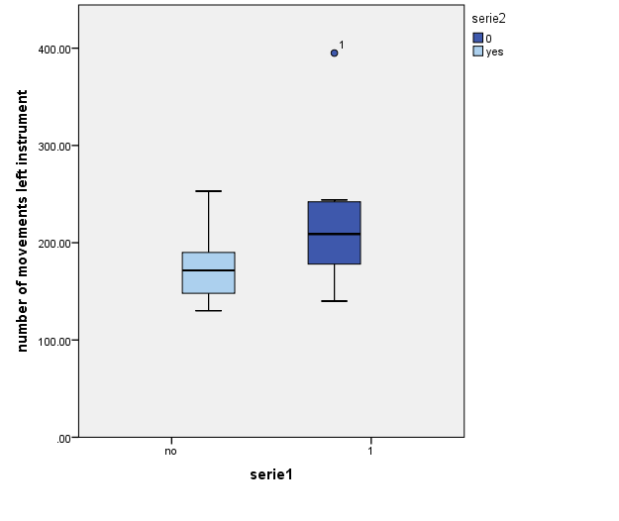
diagram 9 number of left instrument movement task 05
Total Path Length (Right Instrument): The median is lower than the mean.
Total Path Length (Left Instrument): The median is slightly lower than the mean, indicating that most participants showed relatively controlled movement with the left instrument, but a few had significantly more inefficient movements, raising the mean.
As with the right instrument, the wide range (229.00–746.7 cm) reflects variability in movement efficiency.

table 12 task five: descriptive statistics
Parameter | Mean | Median | Min-Max
Time to complete (min) | 129.70 | 118.00 | 91-251
Number of movements left instrument | 196.35 | 187.00 | 130-395
Number of movements right instrument | 199.15 | 183.5 | 144-395
Total path length of right instrument(cm) | 355.63 | 310 | 244-699
Total path length of left instrument(cm) | 359.64 | 350.50 | 229.00-746.7

DISCUSSION:
Simulation-based training offers a controlled, risk-free environment where medical professionals and students can develop and refine laparoscopic assistance skills before performing procedures on actual patients. There was, however, an initial doubt regarding the transfer of skills from the simulators to actual operating theaters.
The findings from this study point out notable differences in participants' performance between the two sessions across multiple key parameters.
Task 01:
camera manipulation 0
the reduction in time suggests improved efficiency, even though the difference was not statistically significant (p = 0.367). this suggests that even if the participants were slightly faster in the second session, the change was smaller to find clear learning or adaptation results, and supports a lack of significance. The median is lower than the mean, suggesting skewed data.
The increase in the number of correct hits was statistically significant (p = 0.025), which shoes a measurable improvement in precision, even though the effect size, at 0.5 hits, might be small, it can be meaningful, particularly in the tasks where in accuracy truly matters. the median matches the maximum (10), indicates that participants achieved perfect scores.
When it comes to the target hit percentage an insignificant improvement has been recorded This implies that while raw correct hits improved, the overall success rate did not change substantially and that might be due to: variability in individual performance that could be the cause of the diluted effect, (min: 52.6%) and (max: 100%), a wide range that reflects variability in performance among participants. The significant decrease in the total path length (p= 0.016) indicates improvement in the camera control and efficiency in movement. the wide range(242.3 cm- 859.7 cm) reflects variability in performance among participants.
A randomized control trial by Aggarwal et al. The United Kingdom showed that the virtual reality trained novice surgeons were able to achieve similar movement dexterity and video rating scores as the experienced surgeons group. However, the overall time was still significantly longer.
Task 02:
camera manipulation 30
the statistically significant decrease in time (p = 0.04) suggests that the participants became more familiar and efficient with the camera 30 degree also the mean included in the min/max range [1.00-3.30] which confirms efficiency but at the same time shows differences in performance among participants (some took 3 times longer). The number of correct hits shows a significant decrease suggests that the participants became more familiar with the camera manipulation from task 01.
Also, target hits have shown improvement but not significantly (p=0.30), and a wide CI 95% that indicates high variability among trainees and that some participants may need more practice.
A significant reduction in the total path length has been recorded, indicates that unnecessary movements are reduced, which is a hallmark of expertise The mean included in the min/max range with max=921.00 suggests that there is unevenness in skill distribution, which may be interpreted as some trainees still lacking precision. A similar trend was observed for target hits.
Task 03:
Eye-hand coordination

a significant decrease in the time needed to complete the task in each session (p=0.02). The finding indicates that the participants completed the task faster after training. The Median < Mean indicates a positive skew in data; in other words, some trainees were slower than others/ struggled to end the task.
When it comes to the economy of movement the no significant change on the right instrument (p=0.71)is due to prior hand dominance, on the opposite, the data coming from the left instrument shows a significant improvement(p=0.03), demonstrating the effectiveness of the LAP MENTOR III in training the non-dominant hand coordination also the left instrument shows a huge range
(12-89cm.60cm) supports that training benefits the non-dominant hand.
some trainees reached the High max 100% at the end of the task, which highlights the effectiveness of the LAP MENTOR III in improving participants' coordination. A systemic review by Nagendran et al. Further concluded that surgical trainees trained with VRLs achieved better operative performance and less operating time in comparison to those using box trainer training or had no training.

Task 04:
Clipping Ducts

The statistically significant reduction in task completion time (p = 0.01) demonstrates that participants became faster and more efficient with training. The improvement in the economy of movement for both the right (p = 0.001) and left instruments (p = 0.007) indicates enhanced control and precision, particularly in tasks requiring bimanual coordination.
These findings are critical because duct clipping is a high-risk step in laparoscopic procedures, and improved movement efficiency reduces potential iatrogenic injuries.
Moreover, the significant increase in the percentage of applied clips (from 71.74% to 89.7%, p = 0.006) supports a notable enhancement in task-specific accuracy. This confirms that participants were not only quicker but also more precise in executing the task after simulation-based training.
The consistency in the number of clipped ducts across both sessions (fixed at 9) eliminates variability in task complexity, ensuring that the observed improvements are indeed due to enhanced skill and not task variation.
However, while median values support the notion of improved performance, the wide range in applied clips (47.40%–100%) suggests that individual differences remain. Some participants reached near-perfect outcomes, while others continued to face difficulties. This points to the need for additional sessions or tailored feedback for certain trainees. In our study, significant improvement was seen in the time taken to complete all the skills and tasks allocated to the surgical trainees. In basic laparoscopic skills, the time taken to complete the skills improved. These results were similar in comparison to the study conducted by Kim et al., which showed an improvement of up to 62% in completion time and up to 32% improvement in accuracy rate.

Task 05:
Peg Transfer
although the reduction in task completion time—from 145.7 minutes to 113.7 minutes—did not reach statistical significance (p = 0.07), the downward trend suggests progressive improvement in time efficiency following simulation-based training. With continued practice, it is reasonable to anticipate that this difference could become statistically meaningful, especially for tasks requiring advanced bimanual coordination.
Similarly, reductions in the number of instrument movements for both the left (p = 0.10) and right (p = 0.14) hands point to improved motion control, although these changes also did not achieve statistical significance. Nonetheless, these trends reflect a general tendency toward more efficient and purposeful movement patterns—hallmarks of technical refinement in laparoscopic performance.
Total path lengths for both instruments decreased slightly in the second session, further supporting this trajectory of improved instrument economy. However, the wide performance variability, particularly in movement counts and time ranges (e.g., 91–251 minutes; 130–395 movements), highlights disparities in individual learning curves. This suggests that while simulation enhances skill acquisition, the rate and extent of improvement may differ across trainees.
The descriptive statistics reveal that some participants demonstrated considerable gains, whereas others required more time and exhibited less efficient movement. This emphasizes the need for personalized feedback, repeated exposure, and possibly task segmentation to ensure uniform progression across all learners. A randomized control trial by Grantcharov et al. in Denmark involving 20 surgeons with limited laparoscopic experience showed significant improvement in operating time, the economy of movement, and fewer errors in comparison with those without training
In summary, Task 5 revealed positive but non-significant trends toward improved performance. These findings affirm the importance of sustained, focused training to master more complex laparoscopic tasks like peg transfer, which involve higher cognitive and motor demands.

Limitations:
The limitations of our study mainly stem from the specific LAP Mentor III simulator, as it features constraints like participant diversity, sample size, and realism. In our study, there was a small number of participants(2 participants) having the same academic and educational background, which may not reflect the full spectrum of surgical learners and potentially limit the generalizability of our findings, and that was clearly seen in the wide CI that suggests the need for larger studies. The non-significant metrics, such as touched targets and the economy of right-hand movement, suggest that a longer, more focused study with a task remodulation by adding smaller targets to increase difficulty could be a game changer in this study.
in addition, our study was based on a single device LAP Mentor III in conclusion the findings may not imply on other VR simulators with different haptic feedback or modules.
Finally, the simulator only trains in dexterity and economy of movement. To perform safe surgery, proper identification of structures is also vital in any surgery. The VRLS is unable to give a more realistic picture and hence limits the identification of real-life anatomy. While this is a good tool to improve motor skills, students will also need to learn to outline important structures in a patient. The use of a laparoscopic simulator aids with training, but it may not transfer skills to a clinical setting.

Conclusion:

This study aims to emphasize the educational value of simulators like the LAP Mentor III in improving surgical skills in a controlled, structured environment.
The various times and scores evaluated showed significant improvement after training with the VRLS, including the five tasks from basic skills to essential ones
The findings supported that VRLS, such as the LAP Mentor III efficiency in surgical training, even suggest that it could be implemented as part of the training tool for surgical trainees in the local setting. So that Learning and training can be achieved in a controlled and safe environment before progressing to the next step of training in the operating theater. Despite its benefits, the study acknowledges the limits encountered, such as the small sample size and the lack of diversity in simulators.
Nevertheless, simulation training is a valuable addition to the typical surgical education, especially now when the focus is on mastering skills.

Figure 34: presentation of our study to Mr. the minister of higher education on his visit to Laghouat simulation center

- BIBLIOGRAPHIC REFERENCES :
- Aggarwal, Rajesh, and others, ‘Proving the Effectiveness of Virtual Reality Simulation for Training in Laparoscopic Surgery’, Annals of Surgery, 246.5 (2007), pp. 771–79, doi:10.1097/SLA.0b013e3180f61b09
- Canu, Gian Luigi, and others, ‘The Application of Augmented Reality in Robotic General Surgery: A Mini-Review’, Open Medicine (Warsaw, Poland), 20.1 (2025), p. 20251170, doi:10.1515/med-2025-1170
- Cardoso, Swizel Ann, Jenisha Suyambu, Javed Iqbal, Diana Carolina Cortes Jaimes and others, ‘Exploring the Role of Simulation Training in Improving Surgical Skills Among Residents: A Narrative Review’, Cureus, 15.9, p. e44654, doi:10.7759/cureus.44654
- Cardoso, Swizel Ann, Jenisha Suyambu, Javed Iqbal, Diana Carolina Cortes Jaimes and others, ‘Exploring the Role of Simulation Training in Improving Surgical Skills Among Residents: A Narrative Review’, Cureus, 15.9 (2023), p. e44654, doi:10.7759/cureus.44654
- Chaudhry, A, and others, ‘Learning Rate for Laparoscopic Surgical Skills on MIST VR, a Virtual Reality Simulator: Quality of Human-Computer Interface’, Annals of the Royal College of Surgeons of England, 81.4 (1999), pp. 281–86
- ‘Fitts and Posner’s Three-Stage Model of Learning. | Download Scientific Diagram’ <https://www.researchgate.net/figure/Fitts-and-Posners-three-stage-model-of-learning_fig1_354451920> [accessed 23 May 2025]
- Grantcharov, T P, and others, ‘Randomized Clinical Trial of Virtual Reality Simulation for Laparoscopic Skills Training’, The British Journal of Surgery, 91.2 (2004), pp. 146–50, doi:10.1002/bjs.4407
- Hamilton, E. C., and others, ‘Comparison of Video Trainer and Virtual Reality Training Systems on Acquisition of Laparoscopic Skills’, Surgical Endoscopy, 16.3 (2002), pp. 406–11, doi:10.1007/s00464-001-8149-z
- Hamitoglu, Ali Emir, and others, ‘Trends and Outcomes of Laparoscopic Surgery in Low-Resource Settings: Lessons From Two African Healthcare Systems-A Narrative Review’, Health Science Reports, 7.12 (2024), p. e70304, doi:10.1002/hsr2.70304
- Jordan, J A, and others, ‘Virtual Reality Training Leads to Faster Adaptation to the Novel Psychomotor Restrictions Encountered by Laparoscopic Surgeons’, Surgical Endoscopy, 15.10 (2001), pp. 1080–84, doi:10.1007/s004640000374
- Kim, Tae Hyo, and others, ‘Assessment of the Laparoscopic Training Validity of a Virtual Reality Simulator (LAP MentorTM’, Korean Journal of Urology, 50.10 (2009), p. 989, doi:10.4111/kju.2009.50.10.989
- ‘Lap Mentor-Based Assessment of Laparoscopic Surgical Skills: A Validation Study’
- ‘Laparoscopy Simulator - LAP Mentor III’, More Than Simulators <https://morethansimulators.com/en/simulator/lap-mentor-iii/> [accessed 23 May 2025]
- ‘LapMentor III Library Modules – Surgical Science’ <https://surgicalsimulation.in/lapmentor-iii-library-modules/> [accessed 23 May 2025]
- McCarrick, Cathleen A, and others, ‘Impact of Simulation Training on Core Skill Competency of Undergraduate Medical Students’, Journal of Surgical Education, 81.9 (2024), pp. 1222–28, doi:10.1016/j.jsurg.2024.06.006
- Moliterno, Nathalia Veiga, and others, ‘High-Fidelity Simulation versus Case-Based Discussion for Training Undergraduate Medical Students in Pediatric Emergencies: A Quasi-Experimental Study’, Jornal de Pediatria, 100.4 (2024), pp. 422–29, doi:10.1016/j.jped.2024.03.007
- Niitsu, Hiroaki, and others, ‘Using the Objective Structured Assessment of Technical Skills (OSATS) Global Rating Scale to Evaluate the Skills of Surgical Trainees in the Operating Room’, Surgery Today, 43.3 (2013), pp. 271–75, doi:10.1007/s00595-012-0313-7
- ‘PubMed Entry’ <http://www.ncbi.nlm.nih.gov/pubmed/21512370> [accessed 23 May 2025]
- Shahrezaei, Aidin, and others, ‘The Impact of Surgical Simulation and Training Technologies on General Surgery Education’, BMC Medical Education, 24.1 (2024), p. 1297, doi:10.1186/s12909-024-06299-w
- ‘Simulation Foundations, Methods and Applications’, Springer <https://www.springer.com/series/10128> [accessed 23 May 2025]
- ‘Simulation in Laparoscopic Surgery 1’
- Spiliotis, Antonios E., Panagiotis M. Spiliotis, and Ifaistion M. Palios, ‘Transferability of Simulation-Based Training in Laparoscopic Surgeries: A Systematic Review’, Minimally Invasive Surgery, 2020 (2020), p. 5879485, doi:10.1155/2020/5879485
- Stefanidis, Dimitrios, and others, ‘Skill Retention Following Proficiency-Based Laparoscopic Simulator Training’, Surgery, 138.2 (2005), pp. 165–70, doi:10.1016/j.surg.2005.06.002
- Steigerwald, Sarah N., and others, ‘The Fundamentals of Laparoscopic Surgery and LapVR Evaluation Metrics May Not Correlate with Operative Performance in a Novice Cohort’, Medical Education Online, 20 (2015), p. 10.3402/meo.v20.30024, doi:10.3402/meo.v20.30024
- Surjeet Sahoo, Shilpi Singh, Renuka Jyothi, ‘The Integration of Simulation-Based Learning in Healthcare Education: Outcomes and Challenges’
- Taffinder, N, and others, ‘Validation of Virtual Reality to Teach and Assess Psychomotor Skills in Laparoscopic Surgery: Results from Randomised Controlled Studies Using the MIST VR Laparoscopic Simulator’, Studies in Health Technology and Informatics, 50 (1998), pp. 124–30
- ‘The Impact of Surgical Simulation and Training Technologies on General Surgery Education | BMC Medical Education | Full Text’ <https://bmcmededuc.biomedcentral.com/articles/10.1186/s12909-024-06299-w> [accessed 23 May 2025]
- ‘Virtual Reality Laparoscopic Simulator: Training Tool for Surgical Trainee in Malaysia’
- Woodfield, Georgia, and others, ‘Development of a North-West London Paracentesis Simulation Course for Core Medical Trainees’, Future Healthcare Journal, 8.1 (2021), pp. e131–36, doi:10.7861/fhj.2020-0153

Abstract
Background:
Laparoscopic surgery requires precise hand-eye coordination and is difficult to learn safely through traditional training. Simulation-based tools like the LAP Mentor III offer structured and risk-free practice. This study evaluates its role in improving laparoscopic assistance skills among surgical trainees in Algeria.
Materials and Methods:
A prospective pilot study was conducted over three months at the IBN ROCHED Simulation Center, Laghouat. Two medical interns with no prior laparoscopic experience performed five tasks on the LAP Mentor III. Key performance metrics (time, accuracy, path length, movement economy) were recorded before and after training. Data were analyzed using SPSS v19.
Results:
Participants showed clear improvements in most tasks, especially in camera handling and clipping, with reduced time and more efficient movements. While some results weren’t statistically significant, the overall trend showed better control and skill development. Trainees also reported higher confidence after the simulation.
Conclusion:
The LAP Mentor III improved core laparoscopic skills in beginners. Despite the small sample size, results support including virtual reality simulation in surgical education before hands-on patient work. Larger studies are recommended to validate these findings.

Résumé
Contexte :
La chirurgie laparoscopique exige une coordination œil-main précise et reste difficile à maîtriser via la formation traditionnelle. Les simulateurs comme le LAP Mentor III offrent un entraînement structuré et sans risque. Cette étude évalue son impact sur les compétences en assistance laparoscopique chez des stagiaires algériens.
Matériels et Méthodes :
Une étude pilote prospective a été menée pendant trois mois au Centre de simulation IBN ROCHED de Laghouat. Deux internes sans expérience préalable ont réalisé cinq tâches sur le LAP Mentor III. Les performances (temps, précision, longueur du trajet, économie de mouvement) ont été mesurées avant et après la formation. L’analyse a été effectuée avec SPSS v19.
Résultats :
Les deux participants ont montré des progrès, notamment en manipulation de la caméra et en clipage, avec des gestes plus rapides et efficaces. Certains résultats n’étaient pas statistiquement significatifs, mais la tendance générale indique une amélioration. Les stagiaires ont aussi exprimé une plus grande confiance après la simulation.
Conclusion :
Le LAP Mentor III a permis d’améliorer les compétences de base en laparoscopie chez les débutants. Malgré la petite taille de l’échantillon, l’étude recommande l’intégration de la simulation VR dans la formation chirurgicale. Des études à plus grande échelle sont nécessaires pour confirmer ces résultats.

