

People's Democratic Republic of Algeria
Ministry of Higher Education and Scientific Research

Amar Thelidji University
–
Laghouat

FACULTY: TECHNOLOGY

DEPARTMENT: PROCESS ENGINEERING

MASTER
THESIS

Presented by:

REZIGUI
Mostapha

BENGHOUINI Meftah Fathi Abdlfatah

DOMAIN: Science and Technology
SECTOR: Process Engineering

OPTION: Chemical
Engineering

Theme

Insight into

the
physical

properties of
the compound

Ag
2
BaSnS
e
4
:

DFT
study

Thesis Defense Committee
:

First

and

last

name

Grade

Quality

BOUTASSOUNA

Nassima

MAA

President

T
AOUTI Mohamed Benabdallah

Professor
Examiner

BELHADJ

Soraya

MCB

Advisor

Academic

year:

202
5

Dedications

Praise be to God, I praise Him and thank Him, Who has guided me to value my academic journey through this memorandum, the result of seventeen
years of seriousness and diligence. As for what follows:
I dedicate this humble work to those who have all the credit for bringing me to this moment to my dear parents, may God protect them and prolong
their lives.
To my dear brothers and sisters, who have always been a source of support
and joy: Lakhder, Yacine, Khadidja, and Amina.
To my partner in this work, the kind colleague Benghouini Fathi, to my loved ones, my friends, my classmates, to everyone who helped me, even
if just a letter, each in his name, each in his position.
My sincere thanks and gratitude to you. May you stay safe and in good
health and may God protect you all.

REZIGUI Mostapha

Dedications

To those who supported me and stood by me every step of the way, to my
family and dear friends, I dedicate this humble work.
To those who taught and guided me throughout my academic career, to my distinguished supervisors and teachers, I dedicate this achievement.
To everyone who believed in and supported me, to my family and loved
ones, I dedicate the fruits of my efforts.

BENGHOUINI Meftah

Acknowledgments

We would like to first of all thank Allah the Almighty Who guided and
helped us to accomplish this modest work.
Our thanks also go to our supervisor Dr. BELHADJ Soraya who spent her time supervising this scientific research and provided us with all the information and advices we needed, so this modest work came to an end
and came into being.
We are also so honored to have Pr. TAOUTI Mohamed Benabdallah and Dr. BOUTASSOUNA Nassima as members in the jury of this work.

And since this work was accomplished within the physics and chemistry of materials laboratory of AMAR THELIDJI University of LAGHOUAT, we would not like to miss the opportunity to thank the head of the
laboratory.
And also, we do not forget to thank the head of Chemical Enginneering option; Dr. BELARBI Faiza and the head of Process Engineering (PE)
department Pr. BENALIA Mokhtar.
We extend our sincere thanks to all the honorable professors of the Process Engineering department and of the Technology faculty and also to all our colleagues, PE students, each in his own name and position and to all the two honorable families, especially our dear parents, may God give them and
our friends a long life.

List of abbreviations

APW: augmented plane wave
DFT: density functional theory
DOS: density of states
FP-LAPW: linear used augmented plane wave method
GGA: generalized gradient approximation

LDA: local density approximation
LSDA: local spin density approximation
TB-mBJ: Tran-Blaha modified Beck-Johnson
E_{H}: hartree energy
EOS: equation of state
H: hamiltonien
𝜺_{𝒓}: dielectric function (real part)
𝛆_{𝐢}: dielectric function (imaginary part)

List of tables

Number Caption Page
Table Ⅰ.1 Mass and electric charges of elementary particles 6
Table Ⅰ.2 Periodic classification of chemical elements principle 7
Table Ⅰ.3 Periodic classification of elements 7
Definition of the crystallographic reference frame and
Table Ⅰ.4 characteristics of the meshes of the seven primitive crystal 12 systems and the fourteen Bravais lattices.
Valence state and Muffin-Tin rays RMT of Ag₂BaSnSe₄
Table II.1 constituent elements 26
The k-points grid (points of sampling of Irreducible
Table II.2 26
Brillouin Zone IBZ)
Table II.3 Ag₂BaSnSe₄ structural parameters 27
Tableau II.4 Atomic coordinates for Ag₂BaSnSe₄ 27
Simulated and experimental structural parameters of
Table II.5 Ag₂BaSnSe₄ 29

Table II.6 Results relating to the band structure of Ag₂BaSnSe₄ 31 Table II.7 Static refractive indices calculated for Ag₂BaSnSe₄ 36
Table II.8 Loss of energy L(ω) of Ag₂BaSnSe₄ (10⁴/cm) 39
Table II.9 Optical gap values (energy at I₀) for Ag₂BaSnSe₄ 39
Table II.10 Values of the birefringence (Δn) of the compound Ag₂BaSnSe₄ 40

List of Figures

 | Number | Caption | Page
Chapter  I | Figure Ⅰ.1 | Main families of materials | 4
Chapter  I | Figure Ⅰ.2 | Simplified representation of an atom | 6
Chapter  I | Figure Ⅰ.3 | Diagrams of band structures | 8
Chapter  I | Figure Ⅰ.4 | Comparing the property value of metal materials based on their property | 9
Chapter  I | Figure Ⅰ.5 | Comparing the property value of organic materials based on their property | 10
Chapter  I | Figure Ⅰ.6 | Comparing the property value of mineral materials based on their property | 10
Chapter  I | Figure Ⅰ.7 | Diagram of a two-dimensional network: mesh N°1 is an example of an elementary mesh(one knot per mesh),mesh N°2 is an example of a multiple mesh | 11
Chapter  I | Figure Ⅰ.8 | Mesh construction | 11
Chapter  I | Figure Ⅰ.9 | Theoretical diagram established according to the theory of Energy bands indicating, depending on the case, the respective position of the valence band and the conduction band | 13
Chapter  I | Figure Ⅰ.10 | Direct band gap | 14
Chapter  I | Figure Ⅰ.11 | Indirect band gap | 14
Chapter  I | Figure Ⅰ.12 | Wien2k code logo | 19
Chapter  I | Figure Ⅰ.13 | Wien2k code structure | 21
Chapter  I | Figure Ⅰ.14 | OriginVer18 logo | 22
Chapter  II | Figure II.1 | (a) Orthorhombic primitive cell of Ag₂BaSnSe₄ | 27
Chapter  II | Figure II.2 | (a) 2D wave-like Ag-Se layer (the Se atoms are omitted for a better view). (b) BaSe8 polyhedra via corner- and edge-sharing to make up the 3D frame work structure in the ac plane with the unit cell marked (left), isolated BaSe8 polyhedra locate in the same tunnel (blue  dashed-box)alone the a-axis (right) | 28
Chapter  II | Figure II.3 | Detailed structure of Ag₂BaSnSe₄ (with some modifications) | 28
Chapter  II | Figure II.4 | Cell volume structural parameters optimization of  Ag₂BaSnSe₄ | 29
Chapter  II | Figure II.5 | Calculated band structure of Ag₂BaSnSe₄ (without TB- mBJ) | 31
Chapter  II | Figure II.6 | Band structure calculated for Ag₂BaSnSe₄ withTB- mBJ | 31
Chapter  II | Figure II.7 | Total and partial density of states calculated for  Ag₂BaSnSe₄ without TB-mBJ | 33
Chapter  II | Figure II.8 | Total and partial density of states calculated for  Ag₂BaSnSe₄ with TB-mBJ | 33
Chapter  II | Figure II.9 | Calculated charge density calculated in a plane  Containing Ag₂BaSnSe₄ and Se atoms | 34
Chapter  II | Figure II.10 | Calculated imaginary ε₂ (ω) and real ε₁(ω) parts of the Dielectric function of Ag₂BaSnSe₄ without TB-mBJ | 35
Chapter  II | Figure II.11 | Calculated imaginary ε₂(ω) and real ε₁(ω) parts of the  Dielectric function of Ag₂BaSnSe₄ with TB-mBJ | 36

 | Figure II.12 | Calculated optical properties for Ag₂BaSnSe₄ as function of the incident photon energy (eV): absorption coefficient I (10⁴/cm), reflectivity R, energy loss L, and refraction index n without TB-mBJ | 38
 | Figure II.13 | Calculated optical properties for Ag₂BaSnSe₄ as function of the incident photon energy (eV): absorption coefficient I (10⁴/cm), reflectivity R, energy loss L, and refraction index n with TB-mBJ | 38
 | Figure II.14 | Calculated birefringence Δn for Ag₂BaSnSe₄ with (b) and without (a) TB-mBJ | 39
 | Figure II.15 | Calculated birefringence Δn for Ag₂BaSnSe₄ without (a) and with (b) TB-mBJ | 40

Content

Content

General Introduction........................................................................................... 1

Chapter I: Bibliographic search
I.1. Introduction ................................................................................................ 3
I.2. Material concepts........................................................................................ 3
I.2.1. Materials choosing ................................................................................ 3
I.2.2 Types of materials .................................................................................. 3
I.2.3. Materials properties .............................................................................. 4
I.2.3.1. Physical properties ............................................................................ 4
I.2.3.2. Mechanical properties ....................................................................... 5
I.3. Classification .............................................................................................. 5
I.3.1. classification of chemical elements ...................................................... 5
I.3.2. classification of materials and properties ............................................. 8
I.3.2.1. Main classes of materials ................................................................. 8
I.3.2.2. Usage properties ............................................................................... 9

I.3.2.3. principle properties of main materials classes.................................. 9
I.4. Crystalline solids ....................................................................................... 10
I.4.1. Crystal structure.................................................................................. 11
I.5. Conductivity ............................................................................................. 12
I.5.1. Semiconductors ................................................................................... 13
I.5.2. Direct gap, indirect gap ..................................................................... 14
I.5.2.1. Direct band gap .............................................................................. 14
I.5.2.1. Indirect band gap ............................................................................ 14
I.5.3. Chemical bonds .................................................................................. 14
I.5.3.1. Strong bonds ................................................................................... 15
I.5.3.2. Weak bonds .................................................................................... 15
I.6. Density functional theory DFT .................................................................. 15
I.6.1. Schrödinger equation .......................................................................... 16
I.6.2. Hohenberg and Kohn theorems .......................................................... 16
I.6.3. Kohn Sham theorem ........................................................................... 17
I.6.4. Exchange potential and LDA and GGA correlation ........................... 17 I.6.4.1. Local Density Approximation (LDA) ............................................ 17
I.6.4.2. Generalized Gradient Approximation (GGA) ............................... 17
I.6.4.3. Approximation WC-GGA ............................................................. 18
I.6.4.4. Approximation PBE-SOL ............................................................. 18
I.6.4.5. Approximation TB-mBJ ................................................................ 18
I.7. Wien2k calculation code ............................................................................ 19
I.7.1. The main steps to follow in the WIEN2K code ................................. 19
I.7.1.1. Initialization..................................................................................... 19
I.7.1.2. SCF calculation ............................................................................... 20
I.7.1.3. Exploring material properties .......................................................... 20
I.8. Origin 2018 ................................................................................................ 21
I.9. Conclusion ...............................................................................................22
References ........................................................................................................ 23

Chapter II: Results and discussion
II.1. Introduction ..............................................................................................25
II.2. Calculation details and parameters .......................................................... 25
II.2.1. Methods adopted ............................................................................. 25
II.2.1.1. Code WIEN2K ........................................................................... 25

II.2.2. Convergence step ............................................................................ 25
II.2.3. Optimization step ............................................................................ 26
II.3. Study of the compound Ag2BaSnSe4....................................................................................... 26
II.3.1. structural properties of Ag2BaSnSe4 ..................................................................... 27
II.4. structural properties .................................................................................. 29
II.5. Electronic properties ................................................................................ 30
II.5.1. Band structure ................................................................................. 30
II.5.2. Density of state ................................................................................ 32
II.5.3. Charge densities .............................................................................. 33
II.5.4. Liner optical properties ................................................................... 34
II.5.4.1. Dielectric function ....................................................................... 34
II.5.4.2. Static refraction indices .............................................................. 36
II.5.4.3. Other linear optical properties .................................................... 37
II.6. Conclusion ................................................................................................ 40
References ........................................................................................................ 41
General Conclusion ........................................................................................... 42

General introduction

General introduction
Since the creation of man in previous eras, science and technology are constantly evolving. We cannot separate one science from another or separate one discipline from another, since sciences are interconnected links that form the chain of the universe, for example, we cannot study a chemical reaction by absence of the laws of physics or the logic of mathematics.
Condensed matter physics and materials science are fundamentally concerned with understanding and exploiting the properties of systems of interacting electrons and atomic nuclei. This has been well known since the development of quantum mechanics. Unfortunately, the electrons and nuclei that make up materials constitute a strongly interacting and this makes solving the Schrödinger equation extremely difficult, and as stated by Dirac; progress depends on the development of sufficiently precise approximate techniques. Thus, the development of density functional theory (DFT) [1] with the local density approximation (LDA) [2] and the generalized gradient approximation (GGA) [3] played an important role in condensed matter physics. These techniques for calculating physicochemical properties are which have now become a basic tool for calculating the structural, electronic and optical properties of the most complex systems. These techniques are based on simulations; that replaced the experiment, sometimes expensive, inaccessible to the laboratory. The basic formalism of DFT is based on the Hohenberg-Kohn theorem [4]. This approach applies to any system with several interacting particles evolving in an external potential, implemented in the wien2k simulation code.
Our objective is to study the properties of compound Ag₂BaSnSe₄ with the wien2k code. So, our work consists of the following parts:
- General introduction.
- CHAPTER I: Bibliographic search.
- CHAPTER II: Computation, results and discussion.
- General conclusion.

1

General introduction

References
- : P. Hohenberg, W. Kohn. Inhomogeneous electron gas. Physical Review 136(3B) (1964) B864-B871.
- : D.M. Ceperley, B.J. Alder. Ground state of the electron gas by a stochastic method.
Physical Review Letters 45(7) (1980) 566-569.
- : J.P. Perdew, Y. Wang. (1992). Accurate and simple analytic representation of the electron-gas correlation energy. Physical Review B 45(23) (1992) 13244-13249.
- : W. Kohn, L.J. Sham. (1965). Self-consistent equations including exchange and correlation effects. Physical Review 140(4A) (1965) A1133-A1138.

2

Chapter I:
Bibliographic search

I.1. Introduction
Human has experimented with a wide range of systems, especially physical ones, that have helped him along his path, life, and progress: metals, insulators, superconductors, even semiconductors, and so on. All these materials have greatly improved the quality of our lives and our progress. Semiconductors have undoubtedly revolutionized the world of physics thanks to their exceptional properties and advantages [1].

I.2. Materials concepts

I.2.1. Materials choosing
Materials are the foundation of technology and industry. Success largely depends on the chosen material. Selecting a material is not a simple task due to the vast diversity available. In the context of product design, the goal of material selection is to minimize cost while achieving optimal product performance. The systematic selection of the best materials begins with evaluating the properties and costs of the candidate materials. Materials are chosen using a material or performance index. For example, a superconductor must have zero electrical resistance internally, which is why an electric current can circulate indefinitely in a superconducting loop even when the battery is disconnected. This is the principle behind the creation of magnetic fields in MRI imaging [2].

I.2.2. Types of materials
A material is a substance of natural or artificial origin that humans use or design to manufacture things they are distinguished according to their origin and properties, whether mechanical (flexible or rigid, etc), chemical (permeable or not, etc) or physical
(conductivity of electricity or heat…).
They are classified into different large families:

• Metallic materials which include
- metals: iron, copper, bronze
- metal alloys: stainless steel
- Organic materials that come from living beings, plants or animals (wood, cotton, paper, etc.)
- Mineral or inorganic materials: rock, ceramic, glass.
- Composite materials: which combine several materials from different families to obtain multiple properties (Example: carbon fiber) [3].
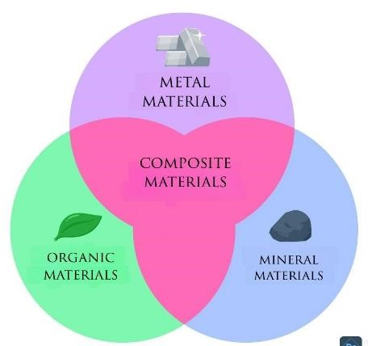

Figure Ⅰ.1: The main families of materials.

I.2.3. Materials properties

I.2.3.1. Physical properties
Pure metals are mostly characterized by high electrical conductivity, thermal conductivity, and density. Silver is the best electrical conductor (6.30×10⁷ S/m), followed by copper (5.96×10⁷ S/m), gold (4.10×10⁷ S/m) and aluminum (3.50×10⁷ S/m) The electrical conductivity of iron is 10⁷S/m, while the electrical conductivity of 1010 carbon steel (0.10% carbon steel) is only 5.9×10⁶ S/m, illustrating the effect of impurities on the conductivity of metals [4]. Although most metals have a greater density than most nonmetals, this varies greatly depending on the material being considered. Among the simple metallic bodies, lithium is the least dense (0.534 g cm⁻³ at 25°C) while osmium is the densest (22.59 g.cm⁻³). Alkali metals (which include lithium) and alkaline earth metals are the least dense of the metals; they are also the least hard, and the alkali metals have a particularly low melting point: With the exception of lithium, they are all liquid at 100 degrees Celsius. The high density of most metals comes from their compact crystalline structure [5].
Metals are characterized by good malleability and high ductility that allows them to deform without breaking. Thus, pure copper can be stretched to form electrical wires and pipes (plumbing), pure gold can be formed into very thin sheets. Conversely, some alloying elements make it possible to harden the metal: for example, the case of carbon, which hardens iron to give steel, and tin, which hardens copper to give brass, in refractory metals, because these elements have a large number of delocalized electrons in their structure. However, other factors also play a role, such as atomic radius, atomic number, number of bonding orbitals, superposition of orbital energies, and type of crystal structure; thus, localized cubic structures give weaker metallic bonds than facecentered cubic structures and compact hexagonal structures because the latter have higher coordination, that is, they bind more neighboring atoms than the former.

I.2.3.2. Mechanical properties
Hooke's law can represent the elastic deformation of metals such that when the deformation is a linear function of stress. The application of forces greater than the elastic limit or heating can lead to permanent deformation of the object (irreversible), which corresponds to plastic deformation [6]. This irreversible modification of the arrangement of the atoms of the material can be caused by:
- Force or action in tension, compression, shear, bending or torsion.
- Heating, which affects the movement of structural defects in the material, such as grain boundaries, gaps, chiral and angular dislocations, and stacking defects in crystalline and non-crystalline solids. The motion of these defects requires activation energy and is therefore limited by the atomic diffusion rate.
- Viscous flow around grain boundaries can lead to creep or metal fatigue. It can also contribute to microstructural changes, such as grain growth and localized increase in material density by eliminating intergranular porosity. The nondirectional nature of metal bonds can contribute significantly to the ductility of solid-state metals [7].

I.3. Classification

I.3.1. Classification of chemical elements
Atoms of chemical elements differ in terms of their structure at the subatomic level, the number and nature of the elementary particles that make them up:
- Nucleus: Protons and neutrons.
- The electron probe that is attracted around the nucleus: Electrons in numbers equal to the protons in the atom at equilibrium [8].
The mass of an electron is negligible compared to that of a proton or neutron (Table Ⅰ.1). Protons are positively charged and electrons are negatively charged, and the elementary charges are equal in absolute values, so that the atom is electrically neutral, i.e. in equilibrium (Figure Ⅰ.2).
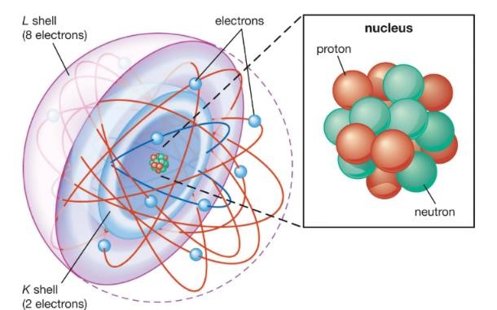

Figure Ⅰ.2: Simplified representation of an atom.
Electron orbitals occupy consecutive layers in the atom, corresponding to discrete energy levels, which become bands in solids with multiple atoms. These levels can only contain a limited number of electrons: Two for the first level, eight for the next (at least when in the outermost position), and separated by forbidden bands. We call the Fermi energy of an atom the upper limit of the filling of electronic energy states at thermodynamic equilibrium and at absolute zero [9].
Table Ⅰ.1: Mass and electric charges of elementary particles.
 | Mass (kg) Mass (amu) Charge (relative) Charge (C)
Proton | 1.67262  1.67493  ×  10  -  27  1.00866  0  0  ×  10  -  27  0.00055  -  1  -  1.60218  ×  -  19  0.00091
Neutron
Electron
In the periodic classification table of the chemical elements, the Mendeleev table (Table Ⅰ.2 and Ⅰ.3), the lines are the successive levels of electron layers. The columns are the number of electrons in the outermost layer. The chemical properties of an element come mainly from its electrons, especially the outermost layer. (valence electrons), and therefore these properties are related to the group (column of the periodic table) to which the element belongs.
Isotopes: Elements with the same atomic number but different atomic masses due to the different number of neutrons (they have the same electronic and chemical properties). In nature, some chemical elements are found as mixtures of isotopes; this results in incorrect average atomic mass values (Table Ⅰ.3).
Group properties: Group VIII elements (rare gases) are characterized by a complete outer layer that gives them exceptional chemical stability.
Group I A elements (Table I.3) have only one electron in their outer layers and they tend to shed it to get a saturated outer layer and give positive ions.
Table Ⅰ.2: The periodic classification of chemical elements principle.
 | Group I | Group II | Group III | Group IV | Group V | Group VI | Group VII | Group VIII
1st period  (K-band) | Z=1 A=1  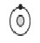  Hydrogen H |  |  |  |  |  |  | Z=2 A=4  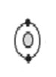  Helium He
2nd period (bands k and l) | Z=3  A=7  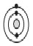  Lithium Li | Z=4  A=9  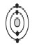  Beryllium Be | Z=5  A=11  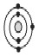  Boron B | Z=6  A=12  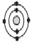  Carbon C | Z=7  A=14  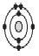  Nitrogen N | Z=8  A=16  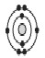  Oxygen O | Z=9  A=19  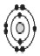  Fluor F | Z=10 A=20  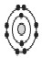  Neon Ne
3rd period (bands k and l and m) | Z=11 A=23  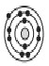  Sodium Na | Z=12  A=24  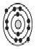  Magnesium Mg | Z=13 A=27  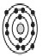  Aluminum Al | Z=14  A= 28  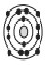  Silicon Si | Z=15 A=31  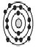  Phosphorus P | Z=16 A=32  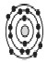  Sulfur S | Z=17 A=35  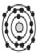  Chlorine Cl | Z=18 A=40  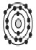  Argon Ar
Table Ⅰ.3: Periodic classification of elements.
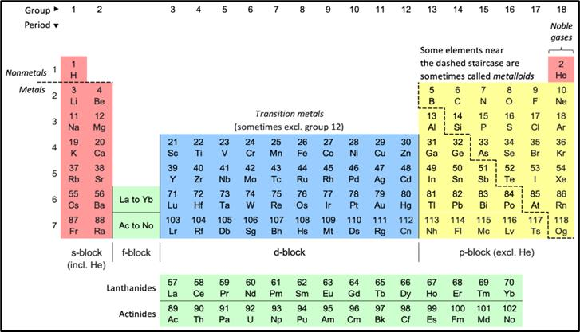
This trend extends to all the elements on the left side of the table (metals), all of which give electrons. The group seven A elements have seven electrons in their outer shells: They tend to complement them by gaining an electron.
This trend also extends to some of the elements on the right side of the table (nonmetals), all of which are electron acceptors. Certain elements that lie on the boundary between these two regions have mixed properties, depending on the electric field to which they are exposed (they are semiconductors). Figure I.3 illustrates these differences in behavior.
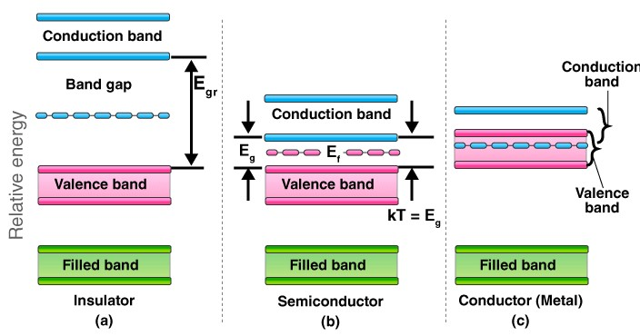

Figure Ⅰ.3: Diagrams of band structures.
- Non-metal atoms (insulator), the band gap has a large width ΔE.
- Semiconductor atoms, the band gap has a small width. • Metal atoms, the conduction band has available states.

I.3.2. Classification of materials and properties

I.3.2.1. Main classes of materials
The physical, chemical, and utilitarian properties of materials are closely related in terms of the nature of the chemical bonds between the atoms that make up the materials, which is how the main categories of materials are distinguished.
a. Metallic substances
These are pure metals and their mixtures consisting mainly of metallic ligands [10].

b. Organic materials
These are materials of biological origin, synthetic polymers and elastomers that include covalent bonds and weak bonds [11].

c. Mineral substances
Rocks, oxides, metallic glasses and ceramics that contain ionic and/or covalent bonds [12].

d. Composite materials
Combine different materials in an organized and precise way, belonging to different categories among the three [13].

I.3.2.2. Usage properties
The physicochemical and use properties of materials can be subject to different classifications (Table I.4). Some of them are mainly conditioned by the nature of atoms and chemical bonds: Density, mechanical and thermal stability, melting temperature, elasticity, brittleness, electrical and thermal conductivity, magnetic properties, etc.
Some are sensitive to the structure by which atoms are arranged and organized:
Plasticity, hardness, plasticity, ductility, tenacity, etc.
I.3.2.3. Principle properties of important classes of materials.

a. Metal materials
Metallic materials are considered have different property values according to the property itself. This is well established in figure I.4.
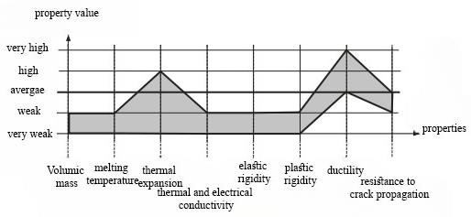

Figure Ⅰ.4: comparing the property value of Metal materials based on their property. b. Organic materials
Relation between property value and property for organic material is represented in figure I.5.
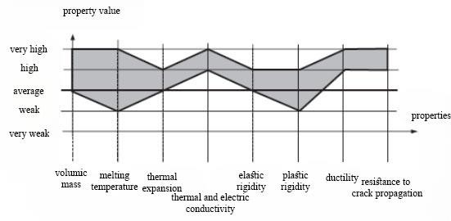

Figure Ⅰ.5: comparing the property value of organic materials based on their property. c. Mineral materials
For mineral materials, figure I.6 illustrates the property value-property relationship.
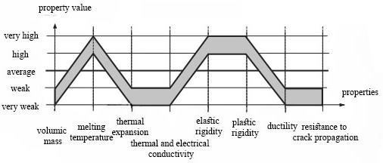

Figure Ⅰ.6: comparing the property value of mineral materials based on their property.

d. Composite materials
The properties of composite materials are variable depending on their composition and the nature of their components: Most are intermediate between the properties of the materials they form, some properties arising from the complete composition of the material and its components) can take on unexpected values.

I.4. Crystalline solids
A crystal is a collection of atoms (or molecules) arranged periodically in three directions and exhibiting both short-term and long-term order. It can be defined from two parameters: Crystal structure and atomic pattern.

I.4.1. Crystal structure
It is a three-dimensional set of imaginary points (nodes) arranged periodically in the three directions of space. It can be generated by repeating an integer number of times three basis vectors that define an initial cell of the original arbitrary grid. Thus, the nodes of the grid are all integer coordinate space points in the chosen basis (Figure Ⅰ.4). The nodes are arranged in rows and grid planes.
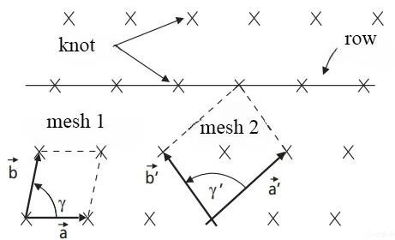

Figure Ⅰ.7: Diagram of a two-dimensional network: Mesh No. 1 is an example of an elementary mesh (one knot per mesh), Mesh N^{º} 2 is an example of a multiple mesh.
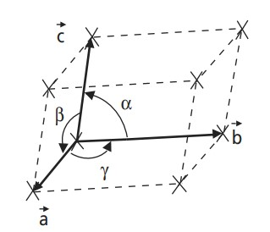

Figure Ⅰ.8: Mesh.
For the selection of the initial cell and its three basic vectors (lengths a, b, c, and angles α, β, γ) there are an infinite number of possibilities, choosing the grid that offers the largest number of symmetry elements, which sometimes leads to the selection of multiple grids. Topological considerations concerning the tiling of three-dimensional space by periodic repetition of symmetric volumes without void or overlap, lead to the conclusion that there can only be seven different types of lattices, defining the seven primitive crystal systems (Figure I.7).
Table Ⅰ.4: Crystallographic parameters and cell parameters of the seven primitive crystalline systems and the fourteen Bravais systems.
Primitive crystal system | Bravais networks | Vector lengths | Vector angles | Examples
Triclinics | Simple |  | 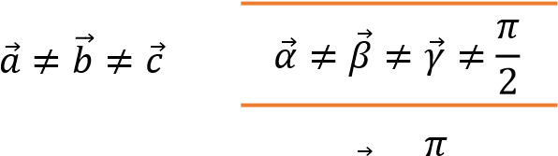𝛼⃗ = 𝛽 = ≠ 𝛾⃗ 2
Monoclinic | Simple With centered bases | 𝑎⃗ ≠ 𝑏⃗⃗ ≠ 𝑐⃗
Orthorhombic | Simple centered with centered bases with centered faces | 𝑎⃗ ≠ 𝑏⃗⃗ ≠ 𝑐⃗ | 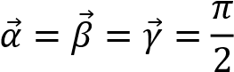 | 𝑈_{𝛼}, 𝐹𝑒₃𝐶
Quadratic | Simple centered | 𝑎⃗ = 𝑏⃗⃗ ≠ 𝑐⃗ | 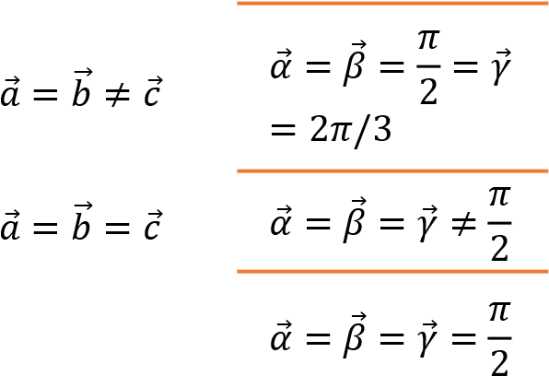 | martensite
Hexagonal | Simple |  |  | Zn, Mg
Rhombohedral | Simple |  |  | As, Sb, Bi
Cubic | Simple centered face-centered | 𝑎⃗ = 𝑏⃗⃗ = 𝑐⃗ |  | Fe, Cu, Ai
In some of these primitive networks, additional nodes can be added to the center of the network, to the centers of two bases, or to the centers of the six faces without losing the periodicity and symmetry properties of the corresponding networks. We obtain fourteen Bravais networks [14].

I.5. Conductivity
Solids are categorized by their conductivity into three types: conductive materials, insulating materials, and semiconducting materials.
We have adapted this classification based on the band structure of the material and the band gap GAP that separates the valence band from the conduction band [15]. In an insulator, the value of the gap is so large that electrons cannot pass from the valence band to the conduction band. In a semiconductor, this value is smaller and equal to zero in the conductor. The valence band is rich in electrons but does not participate in the conduction phenomenon. On the conduction band side, it is empty of electrons. However (metals), the conduction band overlaps the valence band. Electrons can therefore move directly from the valence band to the conduction band and circulate throughout the solid.
In semiconductors, as in insulators, these two bands are separated by a band gap, commonly called a (GAP).
The only difference between a semiconductor and an insulator is the width of this band gap, a width that gives them their respective properties.
The following figure represents E_{Gap} in the three classes of materials.
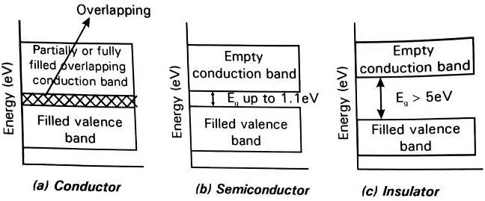

Figure Ⅰ.9: Theoretical diagram established according to the theory of Energy bands indicating, depending on the case, the respective position of the valence band and the Energy band.

I.5.1. Semiconductor
A material that is either electrically conductive or electrically insulating depending on the circumstances. Based on the structure of atoms: Each element of the periodic table has a certain number of electrons arranged around a nucleus. This arrangement in the form of layers of electrons, this variation is responsible for electrical conductivity.
An atom's electrons can have several roles within the structure of the atom:
- Nucleus electrons: They are close to the nucleus and do not interact with other atoms.
- Valence electrons: Located in the outer layers of an atom and make it possible to create bonds between atoms and form molecules.
- Conduction electrons: These are responsible for the circulation of electric current.
In a metal, there are some electrons in both the valence band and the conduction band. This means that the metal can conduct current without any other form of physicochemical manipulation. In an insulator, on the other hand, the two bands are separated by a "gap band": Electrons cannot exist there. In the case of insulators, all the outer electrons are in the valence band and there are no electrons in the conduction band: These materials cannot conduct electricity. In the case of semiconductors, in the center, there's also a band gap, but it's very thin. All it takes is something simple for the valence electrons to pass into the conduction band and that makes the semiconductor conductive. And we can do this by giving energy to the electrons, by exciting them [16].

I.5.2. Direct gap, indirect gap

I.5.2.1. Direct band gap
This is where the bottom of the conduction band and the top of the valence band are at the same value of K. The electron can excite or de-excite directly by absorbing or emitting a photon and there is no phonon interference in the excitation and de-excitation process.
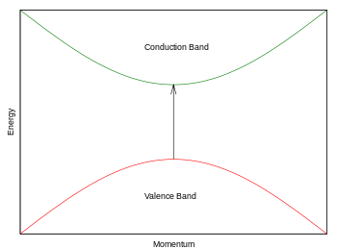

Figure

Ⅰ.
10
:

Direct band

gap
.

I.5.2.2. Indirect band gap
Indirect band gap: Here the top of the valence band and the bottom of the conduction band are at different values of K. If an electron moves from the top of the valence band to the bottom of the conduction band, it has to change its energy as well as the wave vector K [17].
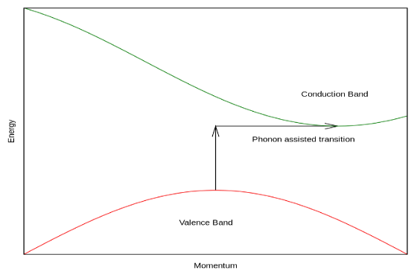
Figure Ⅰ.11: Indirect band gap.

I.5.3. Chemical bonds
The shape of the electron cloud and its energy levels determine the chemical bonds. In solids there are two types of bonds

I.5.3.1. Strong bonds
- Covalent bond: The sharing of two electrons to complete the outermost shell of each atom. It appears between two non-metallic atoms (a bond provided by electrons from the valence band).
- Ionic bond: The transfer of an electron from one atom to another ensures the transfer of an electron from one atom to another. It occurs between an atom of a metal and an atom of a nonmetal. After bonding, the two atoms become electrically charged ions.
- Metallic bond: The sharing of electrons from the peripheral layer; the "gas" formed by these free and delocalized electrons ensures the cohesion of all remaining cations. Appears between elements of a group of metal atoms (a bond provided by conduction band electrons). The electrons in the metallic bond are mobile and available to ensure that an electric current can circulate.

I.5.3.2. Weak bonds
Simple electrostatic attractions between electric charges of opposite sign. They appear between the + and - poles of molecules with inhomogeneous or polarizable charge distributions. They operate over a longer distance, but with less intensity than strong bonds.

I.6. Density functional theory DFT
Density functional theory DFT is used in quantitative calculations of the electronic structure of matter (atoms, molecules, and solids) both in condensed matter physics and in quantum chemistry. The origins of DFT go back to the model developed by Llewellyn Thomas and Enrico Fermi in the late 1920s, the theoretical formalism on which the current method is based was established in the mid-1960s with the contributions of Pierre Hohenberg, Walter Kohn and Le Cham. Methods that respect the tradition in theories of the electronic structure of matter, especially the Hartree-Fock theory and methods derived from this formulation, are based on a multi-electron wave function. The main goal of density function theory is to replace the multi-electron wave function with the electron density as the fundamental quantity for calculations. While the multi-electron wave function depends on 3N variables (where N is the total number of particles in the device), density is a function of only three variables; hence, it is an easier quantity to both mathematically and conceptually. The DFT principle consists of reformulating the N-body quantum problem into a one-body (or, strictly speaking, twobody if we consider spin issues) problem with the electron density as a parameter. The basic idea of DFT theory is that the unique electron density of the device's ground state completely determines the average values of observations such as energy. DFT theory was originally developed primarily within the framework of non-relativistic quantum theory (the time-independent Schrödinger equation) and the Born-Oppenheimer approximation. The theory was then extended to the field of time-dependent quantum mechanics (we then talk about TDDFT for time-dependent density functional theory) and the relativistic field. DFT is also used in the thermodynamic description of classical fluids [18].

I.6.1. Schrödinger equation
The geometric structure, vibration modes as well as other observables describe the electronic structure of the system studied with «N electrons» and «M nuclei». Classical mechanics remains insufficient and we must resort to quantum mechanics, the basis of which is the resolution of the Schrödinger equation. This electronic structure is deduced from the time-independent multi-electron Schrödinger equation:
H. E = . E…………I.1
With:
H: The Hamiltonian operator.
: The wave function of the system.
E: Clean energy.

I.6.2. Hohenberg and Kohn theorems
The development of density functional theory began in 1964 and 1965 with the publications of Hohenberg and Kohn (1964). The two theorems are as follows:
Theorem 01:The total energy of the fundamental state E is a unique functional of the particle density (𝑟⃗)for an external potential 𝑉_{𝑒𝑥𝑡}(𝑟⃗) given. This theorem means that it is enough to know only the electron density to determine all the wave functions. Consequently, the total energy E of a system of interacting electrons in an external potential is represented as a functional of the electron density of the fundamental state,₀ [19].
Theorem02: The total energy functional of any multi-particle system has a minimum which corresponds to the fundamental state. The particle density of the fundamental state verifies:
E[₀] = minE()………..I.2
Hohenberg and Kohn showed that the true density of the fundamental state is that which minimizes the energy[₀], and all other properties are also a functional of this density.
The energy of the fundamental state of an electronic system in an external potential is determined by the variational method [20].

I.6.3. Kohn Sham theorem
In 1965 Kohn and Sham (KS) proposed a practical method for using density functional theory. These authors considered the equivalence between a system of electrons interacting in an external potential V and a system of electrons without interaction in an effective potential 𝑉_{𝑒𝑓𝑓} therefore, the functional of Energy [21].

I.6.4. Exchange potential and LDA and GGA correlation
DFT describes the properties of the ground state, and these practical applications rely on approximations of the correlation exchange potential that describe the effects of the Pauli principle and Coulomb potential beyond the purely electrostatic interaction between electrons. solve the many-body problem by knowing the correlation exchange potential. The Local Density Approximation (LDA), which locally substitutes the energy density E_{xc} for the cross-correlation of a gas-density heterogeneous system, works for electrons of the same density.

I.6.4.1. Local Density Approximation (LDA)
The local density approximation (LDA) consists of treating an inhomogeneous system, as locally homogeneous (uniform gas of interacting electrons where is constant). Consequently, the Energy of exchange and correlation depends only on the electron density at a point r, neglecting any influence of the inhomogeneity of the system (or considers that the density varies very slowly). It is expressed according to the Energy of exchange and correlation per particle [22].

I.6.4.2. Generalized Gradient Approximation (GGA)
Generalized gradient approximation was introduced to improve the accuracy of LDA results. It consists of writing the exchange and correlation Energy not only as a function of the electron density but also of its gradient to take into account the non-uniform nature of the electron gas. This approximation is divided into (03) approximations: o WC-GGA o PBE-GGA o PBE-SOL-GGA

I.6.4.3. Approximation WC-GGA
The estimation of the energy gap is the main gap in the two approximations (GGA and LDA), due to the simple correlation term, Engel and Fusco showed that GGA does not improve the scaling from the second order generalized gradient due to the cancellation of local errors. On the correction made to the correlation term, we mix the second order generalized gradient with the exact Hartree-Fock correlation term: EVGGA is better for gap computation, but remains weak if we are interested in basic energy computations according to structural criteria [23].

I.6.4.4. Approximation PBE-SOL
When describing free-atom energies, common modern generalized gradient estimates are biased. This confusion is removed by recovering a first-principles gradient for exchange over a wide range of density gradients. Perdew et al. introduced a generalized Perdew-Burke-Imzerov gradient approximation that improves the equilibrium properties of densely packed solids and their surfaces.

I.6.4.5. Approximation TB-mBJ
The TB-mBJ approximation was proposed by Tran and Blaha in 2009. It is a modified version of the Beck and Johnson function. The latter has proven to be effective compared to more commonly used calculation methods such as LDA and GGA [24]. In their article published on June 3, 2009 in Physical Review Letters, Tran and Blaha propose a modified version of Beck and Johnson's function, in the form of:
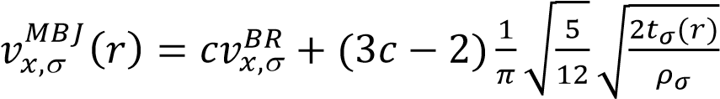 ……………………. I.3
with:
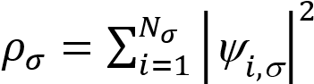 Electron density.
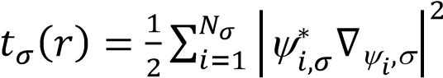 Kinetic energy density.
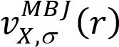 The potential of Becke-Roussel.

I.7. Wien2k calculation code
The WIEN2k package is a computer program written in Fortran which performs quantum mechanical calculations on periodic solids. It uses the full-potential (linearized) augmented plane-wave and local-orbitals [FP-(L)APW+lo] basis set to solve the Kohn–Sham equations of density functional theory.
Peter Blaha and Karlheinz Schwarz from the Institute of Materials Chemistry of the Vienna University of Technology originally developed WIEN2k. The first public release of the code was done in 1990 [25].
Then, the next releases were WIEN93, WIEN97, and WIEN2k.The latest version WIEN2k_23.2 was released in February 2023. It has been licensed by more than 3400 user groups and has about 16000 citations on Google scholar (Blaha WIEN2k).
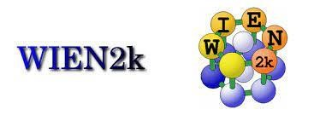

Figure Ⅰ.12: Wien2k code logo.

I.7.1. Main steps to follow in the WIEN2K code
When using this code we generally go through three steps.

I.7.1.1. Initialization
A series of sub-programs are carried out to prepare the SCF course:
N: A program that lists the distances between the nearest neighbors, which helps determine the value of the atomic radius of the sphere (R_{MT}).
SGROUP: A program that determines the spatial group of the structure defined in the CIF.
SYMMETRY: A subroutine that lists the symmetries of the structure's space group from the information in the CIF.
LSTART: A program that generates atomic densities and determines how to handle different orbitals in the calculation of the band structure, such as base cases with or without local orbitals.
KGEN: This subroutine creates a grid of K points in the irreducible part of the first Brillouin zone (IBZ). We specify the number of K points in the entire IBZ.
DSTART: This subroutine produces the first crystal charge density subroutine (case.clmsum), which is an initial density of the SCF (self-consistent field) by superimposing atomic densities.

I.7.1.2. SCF Calculation
The initialization part allowed all the inputs to the SCF cycle to be created, then the process is launched and repeated until the solution converges. This cycle consists of five subprograms:
LAPW0: is a subroutine that calculates the total voltage as the sum of the Coulomb VC voltage and the exchange and link voltage V_{XC}.
LAPW1: is a subroutine that finds the Hamiltonian, interference matrix, eigenvalues, and eigenvectors by the chopping method.
LAPW2: is a subprogram that calculates the valence electron densities from the eigenvectors, uses the energy state, cas.energy and cas.vector and calculates E_{F} (Fermi level).
LCORE: is a subroutine that calculates the fundamental states and densities.
MIXER: is a subroutine that mixes the valence and fundamental densities to produce a new density that is used in the next iteration.

I.7.1.3. Exploring material properties
We have all the data. After calculating the SCF, we have the total energy at equilibrium and the structural parameters, which allow us to examine the properties of the materials we wish to study.
After summarizing the main steps we see in the progress or execution of the WIEN2K code, in the next section we mention the main files needed to execute certain programs or the files generated as output.
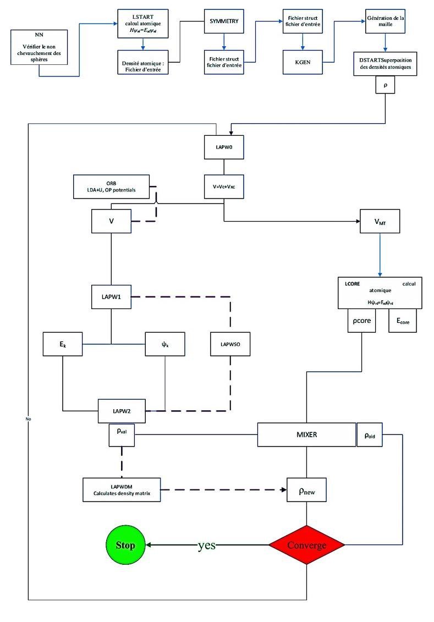

Figure

Ⅰ.
13
:

Wien2k code structure
.

I.8. Origin 2018
Origin is a proprietary computer program for interactive scientific graphing and data analysis. It is produced by OriginLab Corporation, and runs on Microsoft Windows. It has inspired several platform-independent open-source clones and alternatives like LabPlot and SciDAVis.
Graphing support in Origin includes various 2D/3D plot types.

Figure Ⅰ.14: Origin ver.18 logo.
Data analyses in Origin include statistics, signal processing, curve fitting and peak analysis. Origin's curve fitting is performed by a nonlinear least squares fitter which is based on the Levenberg-Marquardt algorithm.
Origin imports data files in various formats such as ASCII text, Excel, NI TDM, DIADem, NetCDF, SPC, etc. It also exports the graph to various image file formats such as JPEG, GIF, EPS, TIFF, etc. There is also a built-in query tool for accessing database data via ADO.

I.9. Conclusion
We have studied matter in general in this chapter, concluding that density function theory is a very effective tool for studying systems of interacting electrons. Indeed, it reduces the issue of N interacting objects to the issue of N independent objects moving in an effective potential.

References
[1]: M.A. Williams. Semiconductor materials for high-speed optoelectronics.
[2]: G.E. Dieter. Overview of the materials selection process (1997). Book chapter;
ASM Handbook, Materials Selection and Design. Page range: 243-254. ASM
International, volume20. ISBN electronic: 978-1-62708-194-8 https://doi.org/10.31399/asm.hb.v20.a0002450 [3]: Chemical physics. Retrieved from CEA:
https://www.cea.fr/comprendre/Pages/physique-chimie/essentiel-sur-materiaux.aspx [4]: W.F. Smith. Principles of materials science and engineering.2nd edition (1990).
Volume 3. Singapore: McGraw-Hill. Book Companies. ISBN10:
0071009361/ISBN13: 9780071009362.
[5]: MatWeb, Your Source for Materials Information. Retrieved from MatWeb: https://matweb.com/
[6]: M.H. Sadd. Elasticity: Theory, Applications, and Numerics (2005), 1st ed.; Elsevier Butterworth-Heinemann: Oxford, UK; pp. 186–189, ISBN 0-12-605811-3.
[7]: Propriétés mécaniques des matériaux Elasticité et plasticité. Retrieved from: https://clarolineconnect.univ-lyon1.fr/clarolinepdfplayerbundle/pdf/3112949
[8]: Atome. Retrieved from wikipedia: https://fr.wikipedia.org/wiki/Atome#
[9]: M. Dupeux, J. Courbon. Aide mémoire: Science et génie des matériaux (2023).5 ed.
Dunod. EAN9782100851942/EAN Ebook : Pdf 9782100856954.
[10]: Metal. Retrieved from wikipedia: https://fr.wikipedia.org/wiki/M%C3%A9tal#cite ref-1 [11]: Organic matter. Retrieved from wikipedia: https://en.wikipedia.org/wiki/Organic_matter [12]: Minéral. Retrieved from wikipedia: https://fr.wikipedia.org/wiki/Min%C3%A9ral [13]: Composite material. Retrieved from wikipedia: https://en.wikipedia.org/wiki/Composite_material [14]: J.Hook, H. Hall. Solid State Physics (2010).
[15]: Band gap. Retrieved from wikipedia: https://en.wikipedia.org/wiki/Band_gap#References [16]: Semiconductors. Retrieved from byjus:
https://byjus.com/jee/semiconductors/
[17]: Direct and indirect band gaps. Retrieved from wikipedia: https://en.wikipedia.org/wiki/Direct_and_indirect_band_gaps
[18]: Density functional Theory and application to atoms and molecules. Physics Reports (2014), 123-239. https://doi.org/10.1016/S0370-1573(97)00083-5
[19]: J. Stephen, C.C. Klippenstein. Density functional theory. In A. C.
Dimian,Computer Aided Chemical Engineering (1997).
[20]: C.C.M. Rindt, S. G.-N. Hohenberg–Kohn theorems. In L. F. Cabeza.Advances in Thermal Energy Storage Systems (2015).
[21]: W.K. Sham. Self-Consistent equations including exchange and correlation effects.
Physical Review, 140, A1133 to A1138 (1965). https://doi.org/10.1103/PhysRev.140.A1133 [22]: Local-density approximation. Retrieved from wikipedia: https://en.wikipedia.org/wiki/Local-density_approximation
[23]: V. Valentin, S.B. Karasiev. Advances in quantum chemistry. InAdvances in Quantum Chemistry (2015) 221-245.
[24]: D. Reyes-Coronado, G. Rodriguez-Gattorno, M.E. Espinosapesqueira, et al. Phase-pure TiO₂ nanoparticles: anatase, brookite and rutile. Nanotechnology 19(14) (2018) 145605. http://doi.org/10.1088/0957-4484/19/14/145605
[25]: P. Blaha, K. Schwarz, P. Sorantin, S. B. Trickey.Comput. Phys. Commun. 59 (1990) 339.

Chapter II:
Computation, results, and

discussion

II.1. Introduction
The materials considered in this study was investigated with regard to its structural, electronic, and optical properties via Ab Initio calculations using the calculation code WIEN2K [1]. The materials studied is the quaternary chalcogenide Ag₂BaSnSe₄; also called selenide.

II.2. Calculation details and parameters

II.2.1. Methods adopted
The calculation launch for each material with WIEN2K is started by the manual introduction of an input density generated by the following data:
- Atomic number Z of each element in the material considered.
- Crystal system (Bravais lattice and space group).
- Cell parameters (a, b, c, α β and 𝛾).
- Positions of atoms (x, y, z).

II.2.1.1. Code WIEN2K
Calculations made with WIEN2k have the following details:
- Method: FP-LAPW; all electron (full potential-linearized augmented plane waves) [2]
- Approximation: WC-GGA (Wu and Cohn Generalized Gradient Approximation)
[3].
- Exchange-correlation potential: TB-mBJ (Tran and Blaha modified BeckeJohnson potential) [4].
- Calculated properties: structural, electronic (band structure, total and partial density of states, and charge density) and linear optical (dielectric function 𝜔, absorption coefficient I, reflictivity R, energy loss L, and index of refraction n).
- Theory: DFPT (density functional pertubation theory) [5].

II.2.2. Convergence step
Before any calculation of properties, convergence studies followed by optimization must be carried out. In the convergence stage, the most important criteria are the relative variations of the total energy as a function of the calculation parameters: RK_{max} and ngkpt parameters.
It should be noted that the choice of the R_{MT} rays (muffin-tin rays) of the atoms (table II.1) is made to reduce the interstitial space as much as possible, because this region is treated by plane waves, which makes the calculation time more important.
The values adopted for the calculation parameters are cross-referenced in (Table II.2).
For the R_{MT} K_{max} parameter it is taken equal to 7 (default values between 6 and 8).
Table II.1: Valence state and Muffin-Tinrays R_{MT} of Ag₂BaSnSe₄ constituent elements.
Element | Valence state | R_{MT} (Bohr)
Ag | 4s24p64d105s1 | 2.34
Ba | 4d105s25p66s2 | 2.5
Sn | 4d105s25p2 | 2.3
Se | 3d104s24p4 | 2.19
Table II.2: The k-points grid (points of sampling of irreducible Brillouin Zone IBZ).
Compound | Grid (ngkpt)
Ag₂BaSnSe₄ | 10x10x10 ª
Ag₂BaSnSe₄ | 12x12x12 ^{b}
ªfor the calculation of structural and electronic properties.
^{b} for calculating optical properties.

II.2.3. Optimization step
The optimization step serves to relax the structure. An optimized structure corresponds to a minimum total energy, with atoms relaxed in a balanced environment translated by minimal resultant forces and Hellmann-Feynman forces (exerted on the atoms) canceled.
The optimization is done using the BFGS program [6]. Often, several cycles are necessary to obtain a well-optimized structure.
It should be noted that optimization with WIEN2K serves to relax the structure.

II.3. Study of the compound Ag₂BaSnSe₄
We have invested the compound Ag₂BaSnSe₄ with regard to the calculation of its properties by the code WIEN2K.
Our objective is to invest the above-mentioned properties by the introduction of the potential TB-mBJ (Becke-Johnson potential modified by Tran and Blaha) in order to obtain more adequate values of the forbidden band (gap-energies) [7]. The TB-mBJ potential turns out to be more precise in estimating the gap for materials containing metals in their structure.
In each step of the calculations (detailed below), our results were compared on one hand with experimental results, and on another hand with theoretical results (if existing).

II.3.1. Structural properties of Ag₂BaSnSe₄
Ag₂BaSnSe₄ crystallizes in the space group I222 (No. 23) of the orthorhombic class (figure II.1),with a = 6.8540Å,b = 7.122Å,c = 8.136Å, and Z = 2 (number of molecules in a unit cell). The corresponding numerical values are reported in Tables II.3 and II.4.
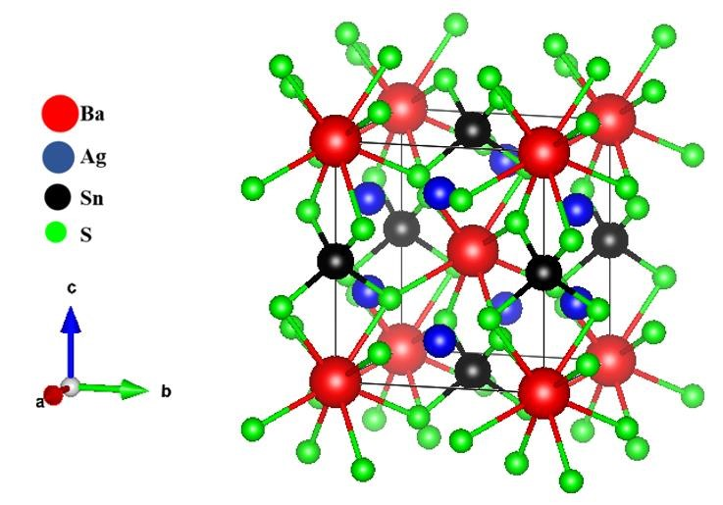

Figure II.1: Orthorhombic primitive cell of Ag₂BaSnSe₄*.
*Drawn from CIF file by VESTA software [8].
Table II.3: Ag₂BaSnSe₄ structural parameters.
a (Å) | b (Å) | c (Å) | 𝜶  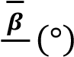  𝜸 | V(Å³)/Z | 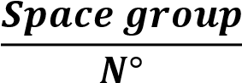 | Crystal class | Ref.
6.885 | 7.122 | 8.136 | 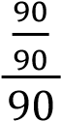 | 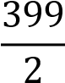 | 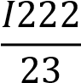 | Orthorhombic | [9]
Table II.4: Atomic coordinates for Ag₂BaSnSe₄ [9].
Atom | x | y | z
Ba | 0 | 1 | 1
Ag | 0 | 0.5 | 0.8066
Sn | 0 | 1 | 0.5
Se | 0.20525 | 1.19603 | 0.6721
The quaternary non-centrosymmetric (NCS) Ag₂BaSnSe₄ was synthesized from a hightemperature solid-state reaction using BaCl₂ flux in evacuated closed silica tubes. In its structure, highly distorted AgSe₄ tetrahedra interconnect together viacorner-sharing to form two-dimensional (2D) layers (figure II.2.a), which are further bridged with isolated SnSe₄ units to produce a three-dimensional (3D) framework structure with Ba cations lying in the tunnels (figure II.2.b). Additional structural details are shown in figure II.3. Remarkably, it not only possesses phase-matchable (PM) ability but also exhibits a good balance between strong SHG response (0.4×AgGaSe₂) and high LIDT (1.5×AgGaSe₂) [9].
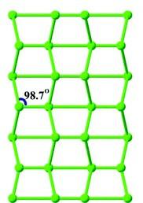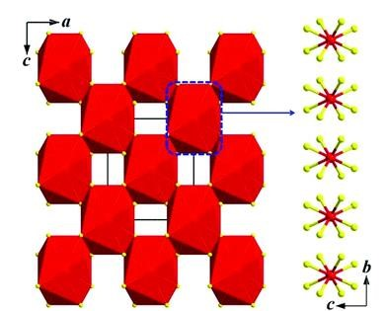
(
a
)
(
b
)

Figure II.2: (a) 2D wave-like Ag-Se layer (the Se atoms are omitted for a better view).
(b) BaSe₈ polyhedra viacorner- and edge-sharing to make up the 3D framework structure in the acplane with the unit cell marked (left), isolated BaSe₈ polyhedra locate in the same tunnel (blue dashed-box) alone thea-axis (right) [9].
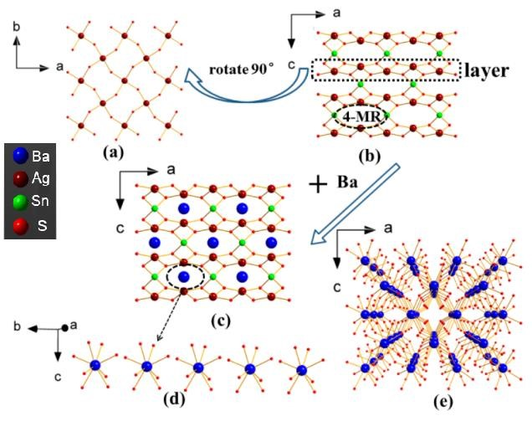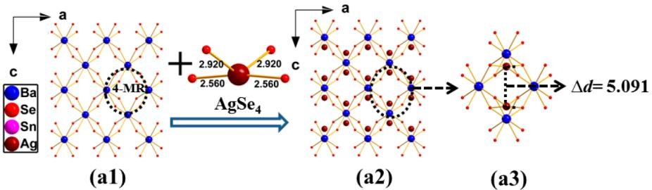

Figure II.3: Detailed structure of Ag₂BaSnSe₄ [9] (with some modifications).
Up: (a) The (2D) [AgSe₄]∞ layer in Ag₂BaSnSe₄. (b) The 2D [AgSe₄]∞ layers are bridged with
[SnSe₄] ligands to make up 4-membered ring (MR) tunnel. (c) The Ba cations located inside the
4-MR tunnels. (d) The [BaSe₈] polyhedra are isolated in the same tunnel. (e) Adjacent [BaSe₈] polyhedra interconnect by corner sharing to form 3D framework.
Down: (a1) [BaSe₈] polyhedra connect with each other to form 4-MR in Ag₂BaSnSe₄; (a2)
[AgSe₄] tetrahedra reside in the 4-MR; (a3) the distance between two Ag atoms in the 4-MR.

II.4. Structural properties
The cell parameters a, b, and c and the atomic positions are calculated and the results are analyzed.
The following general positions are assigned to the constituent elements [9]:
- Ag (0;0.5;z). • Se (0;1;0.5).
- Ba (0;1;1). • Sn (x;y;z).
Then, optimization of volume, c/a ratio, and b/a ratio were carried out and the results are presented in figure II.4. The numerical results are reported in table II.5.
1400
1450
1500
1550
-69338,608
-69338,604
-69338,600
-69338,596
Energy (Ry)
Ag
₂
BaSnSe
₄
Volume (a.u³)
Figure II.4: Cell volume structural parameters optimization of Ag₂BaSnSe₄.
Table II.5: Simulated and experimental structural parameters of Ag₂BaSnSe₄.
Ag₂BaSnSe₄ | Experimental | This work (WC-GGA) | Deviation (%)
a (Å) | 7.101 | 7.130 | +0.410
b (Å) | 7.469 | 7.500 | +0.415
c (Å) | 8.302 | 8.333 | +0.039
V(Å³) | 440.3 | 445.61 | +1.205
From the results reported in table II.4, we note that the values of a, b, and c are estimated with acceptable deviations varying between 0.04% and 0.415% in absolute values. These results are consistent with the general trend of the GGA (FP-LAPW) approximation, which usually overestimates the structural parameters [11]. Note here that the three parameters have conversely been overestimated. Consequently, the volume is overestimated with tolerable discrepancy of 1.205%.
At this point, we deem it necessary to discuss the lengths of bonds by comparing the experimental values with those obtained with the optimized structures.
In fact, we report the following figures:
- For Ba-Se bonds: 3.4162-3.43051 Å calculated versus 3.402-3.417 Å[9]: deviation between +0.417 and +0.395%.
- For Ag-Se bonds: 2.560-2.920 Å [9] versus 2.57095-2.93171 Å calculated: deviation of +0.43 and +0.40%.
- For Sn-Se bonds: 2.512 Å [9] versus 2.52186 Å calculated: deviation of +0.039%.
The calculated bond lengths are very close to the experimental values with deviations ranging between 0.039% and 0.43% and are considered acceptable deviations.

II.5. Electronic properties
The electronic structures of Ag₂BaSnSe₄ have been calculated and the following properties are reported:
- Band structures.
- Electronic densities; partial (PDOS) and total (TDOS).
- Density of states.
The main goal is to know the nature of the bonds between atoms and the electronic behavior of the studied compound.

II.5.1. Band structure
Figures II.5 and II.6 reflect the energies of the band structures calculated at points of high symmetries in the Brillouin zone (BZ) by TB-mBJ.
There are two zones: the conduction band (BC) which corresponds to positive energies, and the valence band (BV) corresponding to negative energies. The latter consists of an inner layer (low energies far from the Fermi level) and an outer layer (near the Fermi level).

The following outcomes are to be illustrated:
- Without TB-mBJ, an indirect gap of 0.028 eV is attributed for our compound Ag₂BaSnSe₄ at the points Γ-Z (figure II.5). The VB maximum is at the point Z and the CB minimum is at the point Γ.
- TB-mBJ undergoes an indirect gap of 0.844 eV at the same points (figure II.6).
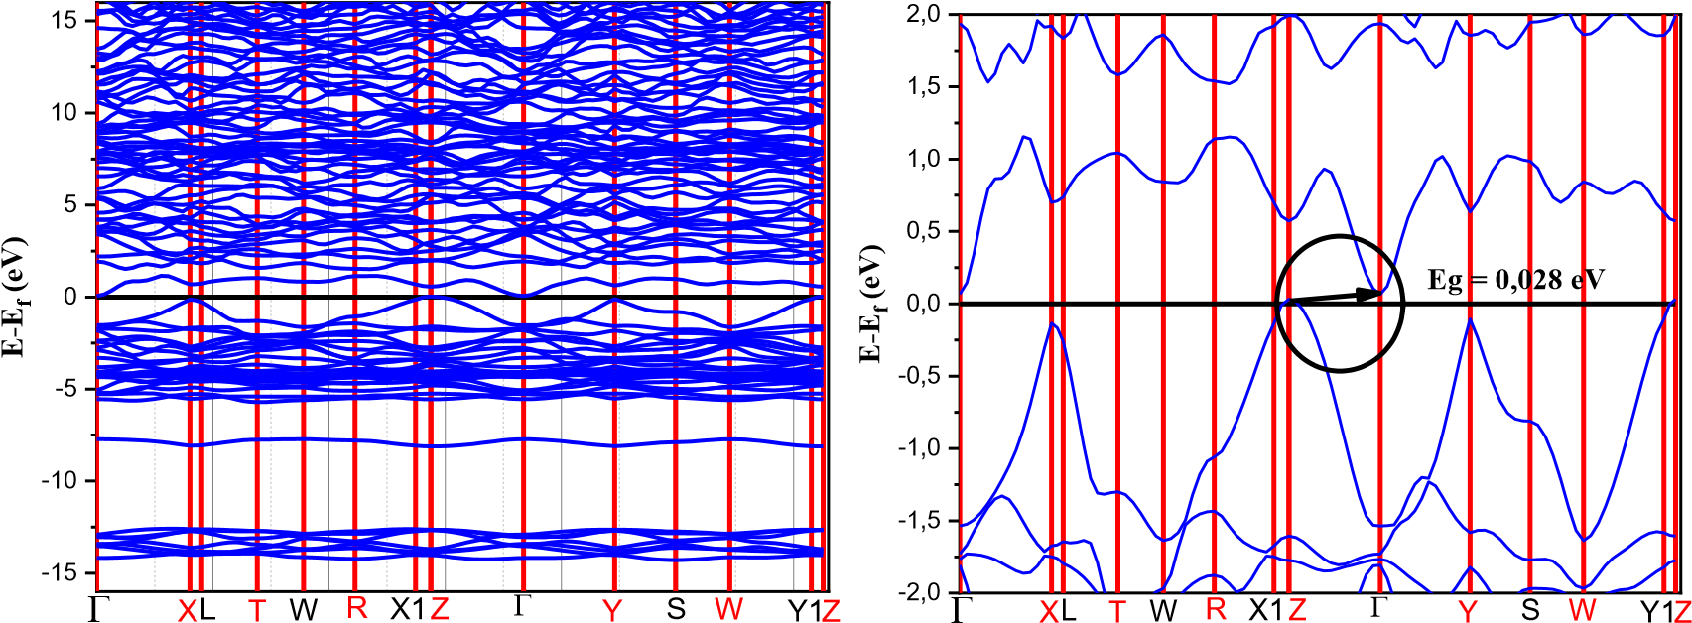
Figure II.5: Calculated band structure (left) of Ag₂BaSnSe₄ (without TB-mBJ), and zoom on the band gap zone (right).
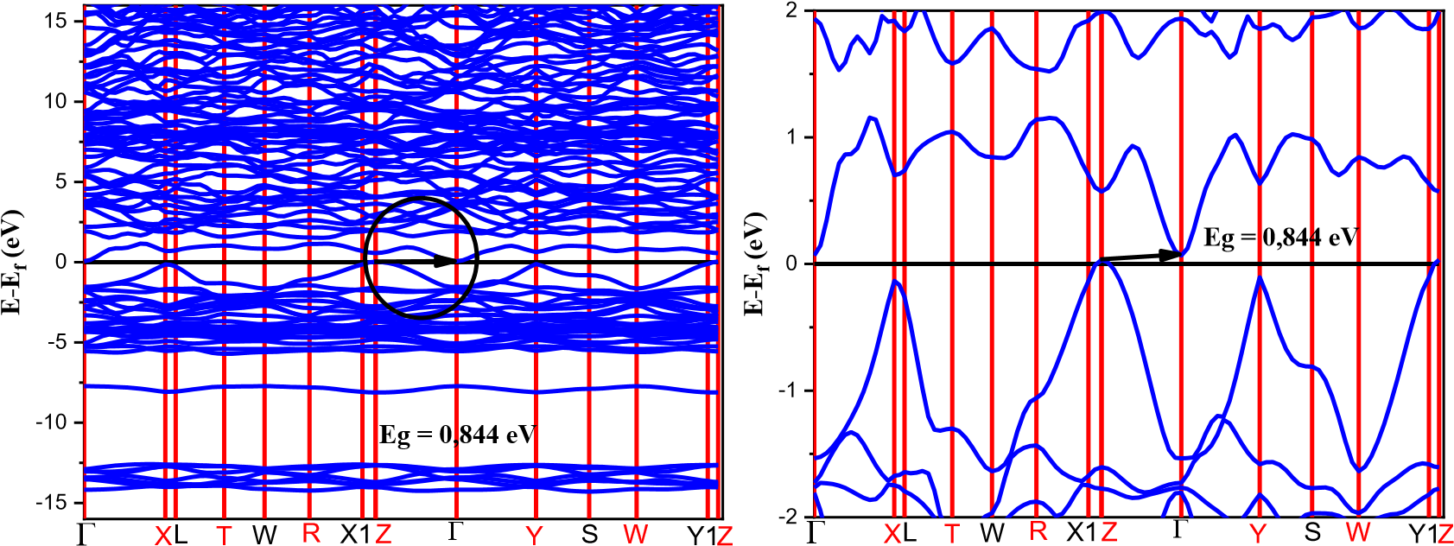
Figure II.6: Band structure calculated (left) for Ag₂BaSnSe₄ (with TB-mBJ), and zoom on the band gap zone (right).
The calculated band structure results are summarized in table II.6, where a comparison with experimental and/or theoretical results is provided.
Tableau II.6: Results relating to the band structure of Ag₂BaSnSe₄.
Compound | Method  WC-GGA |  | Energy gap (eV)
Compound | Method  WC-GGA | Nature | Value | Exp. | Deviation(%)
Ag₂BaSnSe₄ | Without TB-mBJ | IatΓ-Z | 0.02854 | 1.42 [9] | -97.99
Ag₂BaSnSe₄ | With TB-mBJ | I at Γ-Z | 0.844 | 1.42 [9] | -40.56
Ag₂BaSnSe₄ | Théorie [9] | I | 0.605 | 1.42 [9] | -57.39
D : direct. Sign (-) : underestimation. I : indirect. Sign (+) : overestimation.
It is well known that the TB-mBJ gives a better estimation of the band gap energies
(gap) of solids as is the case for the GW method and the hybrid HSE functional (implemented in the CASTEP code) but with a lower cost [12-15].
Thus, our result of 0.844 eV with TB-mBJ is closed compared to the experimental value of 1.42 eV (with -40.56% as deviation). Also, our value is more accurate than that of 0.605 eV reported from another theoretical study in reference [9] (with -57.39 eV as deviation) where authors did not adopt the HSE implemented in CASTEP code. Our obtained results are slightly less than those reported for commercialized NLO chalcopyrite materials: AgGaQ₂ (Q = S, Se) and ZnGeP₂ [9, 16], which guaranties to our material a larger transparency range and a better damage threshold (DTS) compared with the above mentioned chalcopyrites. This is due to the existence of correlation between gap value and optical DTS [16].

II.5.2. Density of states
The optical behaviors of materials are closely linked to electronic transitions from valence bands (BV) to conduction bands (BC), we then present densities of states (DOS) to identify the characteristics (structures) of electronic states.
We show in figures II.7and II.8 the calculated total (TDOS) and partial (PDOS) state densities of the studied selenide. The Fermi level stands at 0eV.
As illustrated in these figures, we observe similarities in the shape of the densities with slight differences in the positions of the states as well as in their intensities.
Generally, the bands are narrow and relatively intense in the inner layer of the BV but moderately intense and broad near the fermi level. In BC, the bands are wider and relatively weak in intensity.
A deeper analysis of the densities of states reveals the following remarks:
The PDOSs were achieved and we find out that in the VB region below the Fermi level, the Ag-4d and Se-3p states dominating the VB-1 region are mixing with minor Sn-5s and Sn-5p states. Above the Fermi level, the CB-1 region is derived primarily from the Se-3p and Sn-5s states mixing with small amounts of Ag-4d and Sn-5p states.
The Ba atoms almost make no contribution around E_{F} and act as electron donors to stabilize the structure. Therefore, the band gap absorptions are primarily ascribed to the charge transitions from the Se-3p states to Ag-4d, Sn-5s, and Sn-5p states.
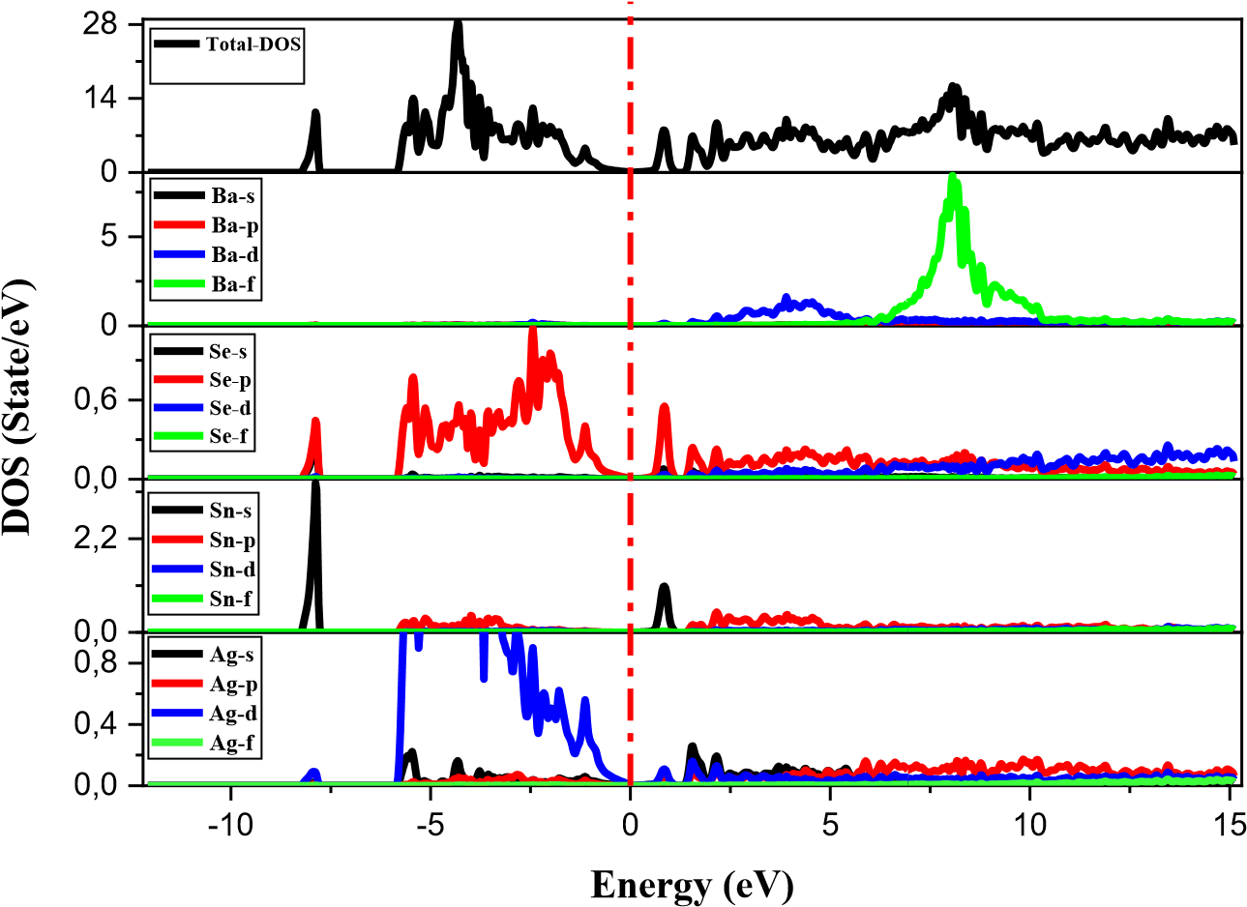

Figure II.7: TDOS and PDOS calculated for Ag₂BaSnSe₄ without TB-mBJ.

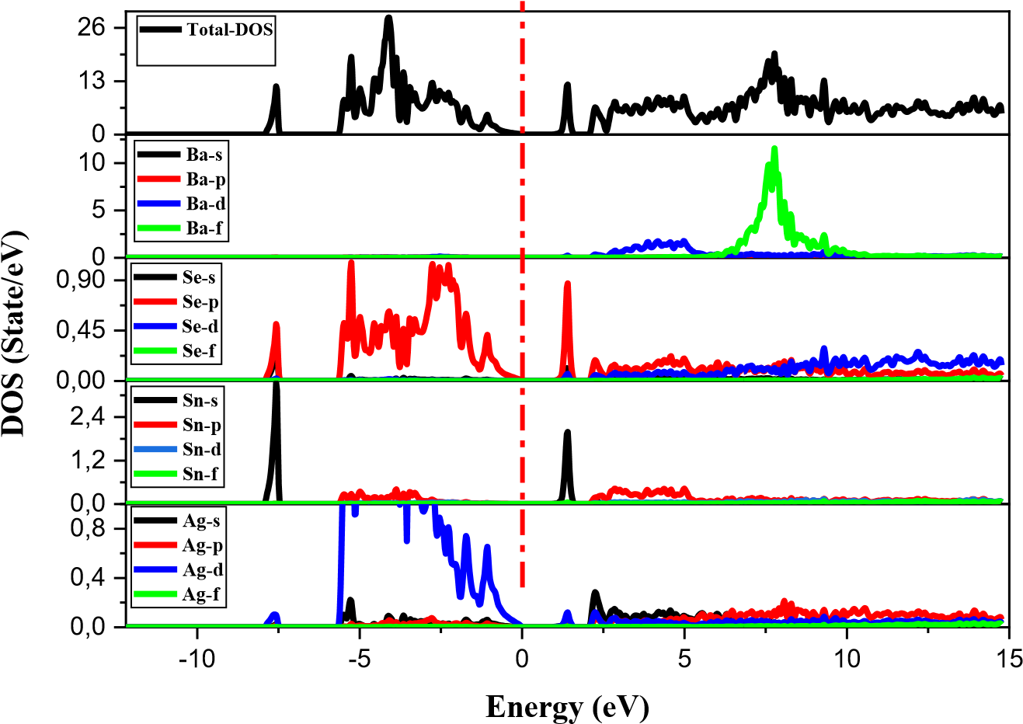
Figure II.8: TDOS and PDOS calculated for Ag₂BaSnSe₄ with TB-mBJ.

II.5.3. Charge densities
The electronic charge density shows us the nature of the bonds in compounds, whether they are ionic, covalent or even mixed in nature.
The calculation of the charge densities leads into the results interpreted in figure II.9. Each projection translates the contours of the charge density on a plane containing the four atoms Ag, Ba, Sn, and Se.
For charge density of Ag₂BaSnSe₄, the following remarks are noted:
- For Ag and Se atoms, the contours are also deformed, thus Ag-Se bond is mainly covalent (charge transitions from the Se-3p to Ag-4d states; from DOS results).
- The symmetry is almost spherical around the Ba and Se atoms with a very slight deviation towards each other which indicates that the Ba-Se bond is mainly ionic with a very weak covalent tendency. This result is a confirmation to the DOS results indicating the electron donor behavior of the Ba atom in order to stabilize the structure.
- Around atoms Sn and Se, the contours are well deformed, indicating thus a covalent Sn-S bond character. This correlates with the charge transitions from the Se-3p states to Sn-5s and Sn-5p states (from DOS results).
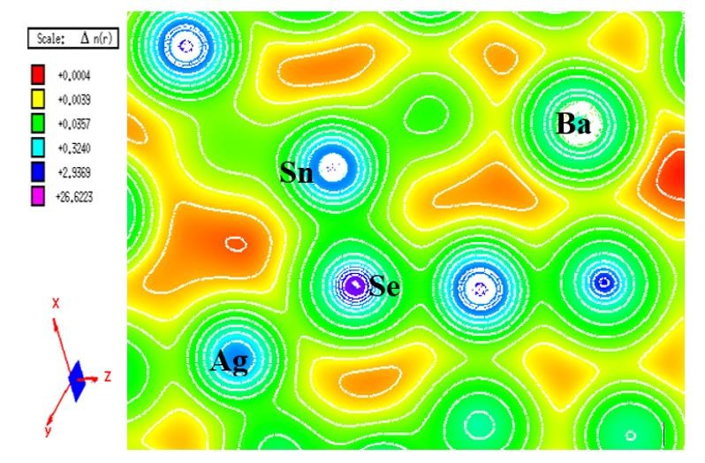

Figure II.9: Charge density calculated in a plane containing Ag, Ba, Sn, and Se atoms.

II.5.4. Liner optical properties

II.5.4.1. Dielectric function
The dielectric constant ε(ω) is the keystone for the exploitation and interpretation of the linear optical properties of materials. It is a complex function with a real part ε₁(ω) and an imaginary part ε₂(ω).The dielectric function (ε) is a measure of how a material responds to an electric field.
The imaginary part of the dielectric function is calculated from the probabilities of electronic transitions between valence band and conduction band. Its formula is given by the following equation [17]:
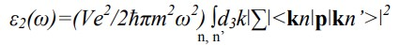 𝑋𝑓(𝐾𝑛)(1 − 𝑓(𝐾𝑛’))δ(𝐸_{𝐾𝑛} − 𝐸_{𝐾𝑛} − ħω) II.1
With:
- V: cell volume.
- e: electron charge.
- m: electron mass.
- ħω: energy of the incident photon.
- ƒ(kn): Fermi-Dirac distribution.
- p: angular momentum operator.
- kn: wave function.
For the real part, the calculation is done using the following relation [18-20]:
……... II.2
The calculations carried out on the dielectric functions (real parts ε₁(ω) and imaginary parts ε₂(ω)) led to the results illustrated in figures II.10 and II.11.
The peaks in the imaginary part of the dielectric function correspond to electronic transitions between valence bands and conduction bands.
0
6
12
0
2
4
6
8
10
12
0
5
10
Dielectric Function

Re xx

Re yy

Re zz
Energy (eV)
Im xx
Im yy

Im zz

Figure II.10: Calculated imaginary ε₂(ω) and real ε₁(ω) parts of the dielectric function of Ag₂BaSnSe₄ without TB-mBJ.
According to the results obtained, our material presents major peaks corresponding to electronic transitions from Se-3p (BV) toward Sn-5p,5s (BC). Transitions from Se-3p (BV) toward Ag-4d (BC) also participate.

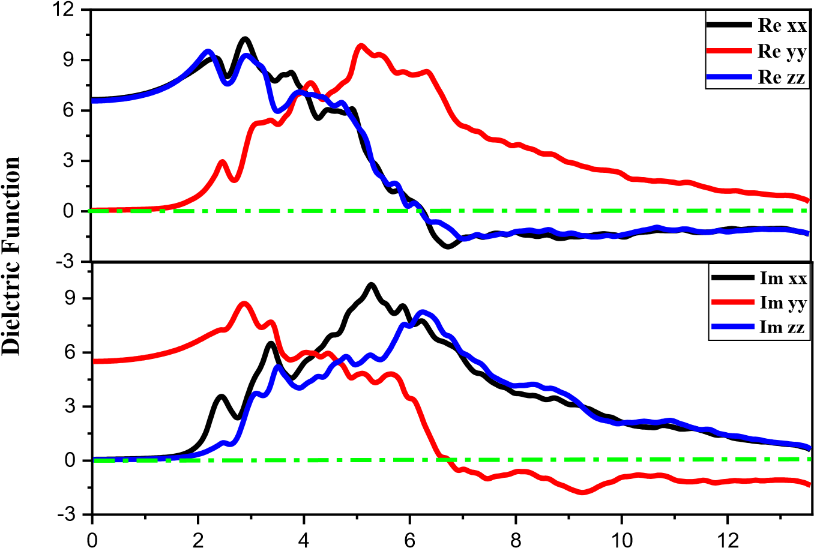
Energy (eV)
Figure II.11: Calculated imaginary ε₂(ω) and real ε₁(ω) parts of the dielectric function of Ag₂BaSnSe₄ with TB-mBJ.

II.5.4.2. Static refraction indices
The refractive index (n) is a measure of how much a material slows down light compared to its speed in a vacuum. It's a property that depends on the frequency (or wavelength) of light.
The static refractive indices are calculated from the real part of the dielectric function at ε₁(0), this is its most important quantity. The static refractive index, n(0), is related to the static dielectric function ε(0) through the formula: n(0) = √ε(0). Table II.7 presents the obtained values.
Tableau II.7: Static refractive indices calculated for Ag₂BaSnSe₄.
Ag₂BaSnSe₄ | 𝒏(𝟎)_{𝒙}=n₀ | 𝒏(𝟎)_{𝒚} | 𝒏(𝟎)_{𝒛}=n_{e}
Without TB-mBJ | 2.9913 | 2.9984 | 2.6728
With TB-mBJ | 2.5728 | 2.5581 | 2.3419

II.5.4.3. Other linear optical properties
All other properties can be calculated from both the real and imaginary parts of the dielectric function:
- Absorption I(ω): to estimate the optical gap.
- Reflectivity R(ω).
- Energy loss L(ω): describes the energy of an accelerated electron passing through the crystal.
- Refractive index n(ω).
The equations II.4 to II.7 below allow the calculation of these properties.
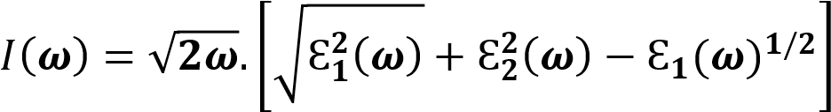 II.4
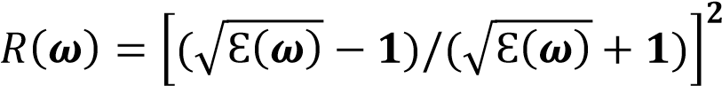 II.5
𝐿(𝝎) = Ԑ_{𝟐}(𝝎)/(Ԑ^{𝟐}_{𝟏}(𝝎) + Ԑ^{𝟐}_{𝟐}(𝝎)) II.6
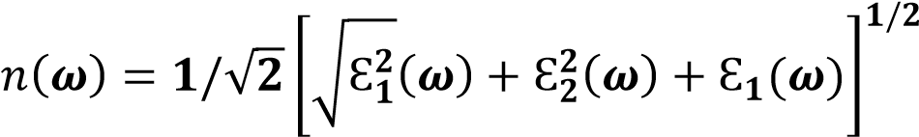 II.7
The calculation results obtained for these four parameters are illustrated in figures II.12 and II.13.

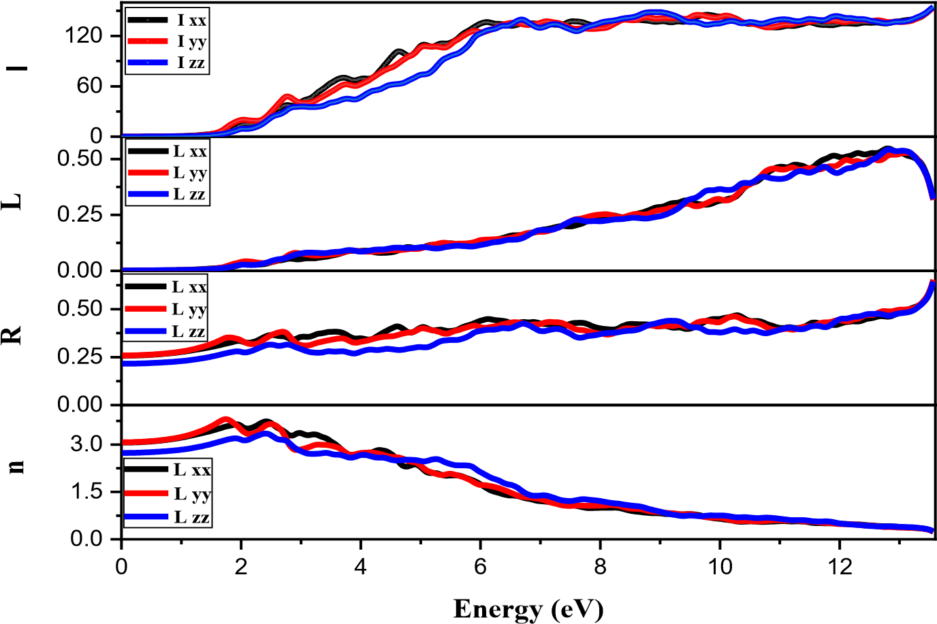
Figure II.12: Calculated optical properties for Ag₂BaSnSe₄ as function of the incident photon energy (eV): absorption coefficient I (10⁴/cm), reflectivity R, energy loss L , and refraction index n (without TB-mBJ).

0
80
160
0.0
0.2
0.4
0.0
0.3
0.6
0
2
4
6
8
10
12
0.0
1.5
3.0
I

L xx

L yy

L zz
L

L xx

L yy

L zz
R

L xx

L yy

L zz
n
Energy
(
eV
)
L xx

L yy
L zz

Figure II.13: Calculated optical properties for Ag₂BaSnSe₄ as function of the incident photon energy (eV): absorption coefficient I (10⁴/cm), reflectivity R, energy loss L, and
refraction index n (with TB-mBJ).
In the energy loss L(ω) diagram, the most important pic corresponds to the plasma frequency ω_{p} where we notice a sharp reduction in reflectivity R(ω).Values of energies corresponding to those characteristic pics are grouped in table II.8.

Tableau II.8: Energy loss L(ω) parameters of Ag₂BaSnSe₄ (10⁴/cm).
Ag₂BaSnSe₄ | En | ergy loss L(ω) at ω_{p} (10⁴/cm)
Ag₂BaSnSe₄ | 𝐋(𝛚_{𝛒})_{𝐗𝐗}(𝐞𝐕) | 𝐋(𝛚_{𝛒})_{𝐲𝐲}(𝐞𝐕) |  | 𝐋(𝛚_{𝛒})_{𝐙𝐙}(𝐞𝐕)
Without TB-mBJ | 0.5064 (12.78) | 0.5571 (13.08) |  | 0.5561 (12.80)
With TB-mBJ | 0.5058 (12.91) | 0.4877 (12.61) |  | 0.4806 (12.97)
From the absorption spectra I(ω) we can derive the values of the optical gaps of our material. The values for Ag₂BaSnSe₄ are represented in table II.9.
Tableau II.9: Optical gap values (energy at I₀) for Ag₂BaSnSe₄.
Ag₂BaSnSe₄ | E | nergy at I₀ ≡ Optical gap (e | V)
Ag₂BaSnSe₄ | 𝐄[𝐈(𝟎)_{𝐗𝐗}] | 𝐄[𝐈(𝟎)_{𝐲𝐲}] | 𝐄[𝐈(𝟎)_{𝐙𝐙}]
Without TB-mBJ | 0.9388 | 0.966 | 1.0748
With TB-mBJ | 1.347 | 1.3742 | 1.5374
Optical gap values obtained are larger than our electronic gap value but very close to the experimental one indicating the reliability of our calculations.
The birefringence Δn (n_{e}-n₀) informs us about the nature of the material (uniaxial or biaxial, positive or negative).
The birefringence is illustrated in figures II.14 and II.15 and its static limit values and its maximum values with their corresponding energies are indicated in table II.10.
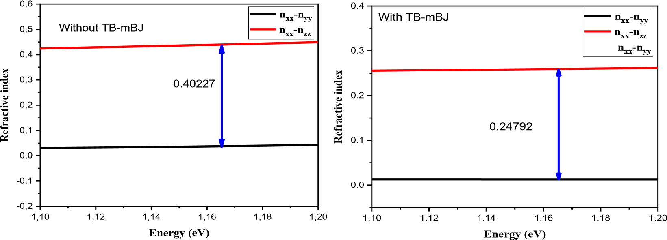

(a) (b)
Figure II.14: Calculated birefringence Δn for Ag₂BaSnSe₄ without (a) and with (b) TBmBJ.
0
2
4
0.0
0.1
0.2
0.3
0.4
0.5
0.6
0.7
Refractive index
Energy (eV)

n
xx
-
n
yy
n
xx
n
-
zz

n
xx
-
n
yy
Without TB-mBJ
0
2
4
6
0.0
0.1
0.2
0.3
0.4
0.5
Refractive index
Energy (eV)

n
xx
-
n
yy
n
xx
n
-
zz

n
xx
-
n
yy
With TB-mBJ

(a) (b)
Figure II.15: Calculated birefringence Δn for Ag₂BaSnSe₄ without (a) and with (b) TBmBJ.
Table II.10: Values of the birefringence (Δn) of the compound Ag₂BaSnSe₄.
Ag₂BaSnSe₄ | Birefringence (Δn)
Ag₂BaSnSe₄ | At the static limit |  |  | Maximum value (energy in eV)
Ag₂BaSnSe₄ | xx-yy | xx-zz |  | xx-yy | xx-zz
Without TB-mBJ | 0.011 |  | 0.263 | 0.511 (3.44) | 0.580 (2.03)
With TB-mBJ | 0.019 |  | 0.157 | 0.372 (4.23) | 0.436 (6.65)
Concerning the maximum value of birefringence for our material, it can be noted from the reported values (table II.10) that the large values are located at lower energies while the less important values are located at lower energies. This means that the more the max value of birefringence increases the more it will be at a lower energy.
In addition, we extract birefringence values at 2050 nm (equivalent to 0.61 eV) and we find out the value of 0.088 which is clearly larger than that of 0.039 calculated for AgGaSe2 (AGS); taken as benchmark [10].

II.6. Conclusion
From the reported results, we can conclude that our material is a semiconductor of choice with a more or less wide transparency window. Also, from the calculated properties, we found that TB-mBJ considerably improves the estimation of the electronic properties and especially that of the band gap.
On the other hand, the choice of approximation turns out to be important because the results of the calculated properties change from one approximation to another.

References
[1]: P. Blaha; K. Schwarz; G.K.H. Madsen; D. Kvasnicka; J. Luitz; R. Laskowski; F. Tran; L.D. Marks. WIEN2K An augmented plane wave plus local orbitals program for calculating crystal properties. Vienna University of Technology. Austria (2018).
[2]: J.C. Slater. Wave functions in a periodic potential. Phys. Rev. 51 (1937) 846. https://doi.org/10.1103/PhysRev.51.846
[3]: K.P. Perdew, K. Burke, M. Ernzerhof. Phys. Rev. Lett. 77(18) (1996) 3865.
[4]: K. Schwarz, P. Blaha, G.K.H. Madsen. Computer Physics Communications 147 (2002) 71.
[5]: S. Baroni, S. deGironcoli, A. Dal Corso, P. Giannozzi. Rev. Mod. Phys. 73 (2001) 515.
[6]: H.B. Schlegel. J. Comp. Chem. 3 (1982)214.
[7]: F. Tran, P. Blaha. Phys. Rev. Lett. 102 (2009) 226401.
[8]: K. Momma, F. Izumi. J. Appl. Cryst. 44 (2011) 1272: VESTA (Vizualization for Electronic and Structural Analysis) Ver. 3.4.2. (2017).
[9]: L. Nian, K. Wu, G. He, Z. Yang, S. Pan. Inorg. Chem.
[10]: H. Chen, P-F. Liu, B-X. Li, H. Lin, L-M. Wu, X-T. Wu. Dalton Trans. 47 (2018) 429.
[11]: B. Lagoun, B. Bentria, I.K. Lefkaier. Physica B 433 (2014) 117.
[12]: J.P. Perdew, A. Ruzsinszky, G.I. Csonka, O.A. Vydrov, G.E. Scuseria, L.A.
Constantin, X. Zhou, K. Burke. Phys. Rev. Lett. 102 (2009) 039902.
[13]: R. Abt, C. Ambrosch-Draxl, P. Knoll. Physica B 194 (1994) 1451.
[14]: C. Ambrosch-Draxl, J. O. Sofo. Comput. Phys. Commun. 175 (2006) 1.
[15]: D. J. Singh. Phys. Rev. B 82 (2010) 205102.
[16]: O. Madelung. Semiconductors: Data Handbook. 3rd ed. Springer. Berlin (2004).
[17]: S. Saha, T.P. Sinha. Phys. Rev. B 62(13) (2000) 8828.
[18]: H.A. Kramers. Nature 113(2845) (1924) 673.
[19]: H.A. Kramers. Nature 114(2845) (1924) 310.
[20]: R. _{DE} L. Kronig. J. Opt. Soc. America 12(6) (1926) 547.

General conclusion

General conclusion

In this work, we have studied the structural, electronic (band structure, density of states), and optical (dielectric function, absorption coefficient, reflectivity, energy loss, refractive index) properties of the compound Ag₂BaSnSe₄ by the method of linearized augmented plane wave at full potential (FP-LAPW) in the framework of DFT, it is treated with the approximation of the generalized gradient approximation (GGA), implemented in the code WIEN2K.
In this conclusion, we would like to emphasize the following essentiall points: first of all, we studied the structural properties which characterize the ground state of the system considered such as the equilibrium volume. Our results are in very good agreement with experimental results.
Next, we determined the electronic properties which indicate that our compound has indirect gap.
The DOS allowed us to examine the different coordination modes of Ag₂BaSnSe₄, we obtained the nature of the bond Sn-Se (covalent) and for Ag-Se is mainly covalent, while Ba-Se bond is mainly ionic.
To study the behavior of our semiconductor compound with respect to light, we calculated its optical properties such as the dielectric function, reflectivity, absorption coefficient, refractive index, etc.
Finally, according to our short experiment on the use of the WIEN2K code it turns out that this program is a very powerful code which allows the prediction of most of the physical properties of materials.

42

